Cogston House - example

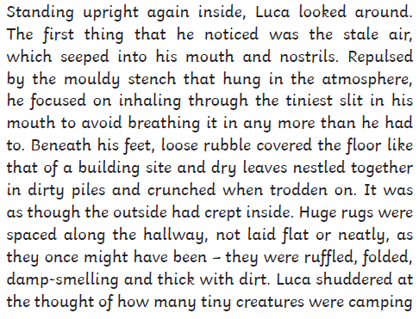

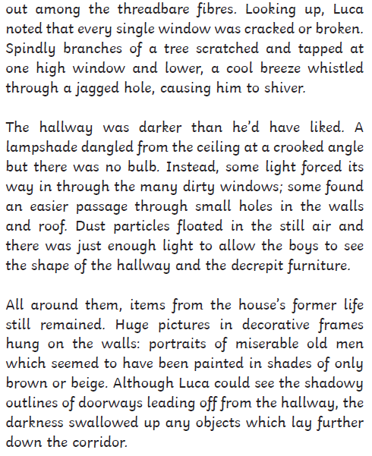 Planner

Setting – What objects can you see? What’s the weather like? Where is the descriptive writing taking place?

What weather elements are you going to include?

Language – what words are you going to magpie from Cogston House? Have you any other words of your own to use?

Write down some of the sentence starters you might magpie from Cogston House



picture