**DIARY DATES**

**October**

10th- Harvest service @ church

15th-16th -Bikeability Y6 (grp 1)

22nd-23rd - Bikeability Y6 (grp 2)

28th- 1st Half Term

**November**

4th- Non-Pupil Day Staff Training

5th- School individual photos

6th- Y5/6 Dodgeball

11th- KS2 Music festival

14th- Flu jabs

**December**

6th- Christingle @2.15

18th- Christmas Jumper Day & Panto (kindly provided by FoF)

19th- Christmas service @ church @2.15

19th End of Autumn Term

 Fordham News

Headteacher– Jakki Sibley

Acting Deputy Headteacher- Alison Crawley

admin@allsaints-fordham.essex.sch.uk

September 2019



Settling in September!

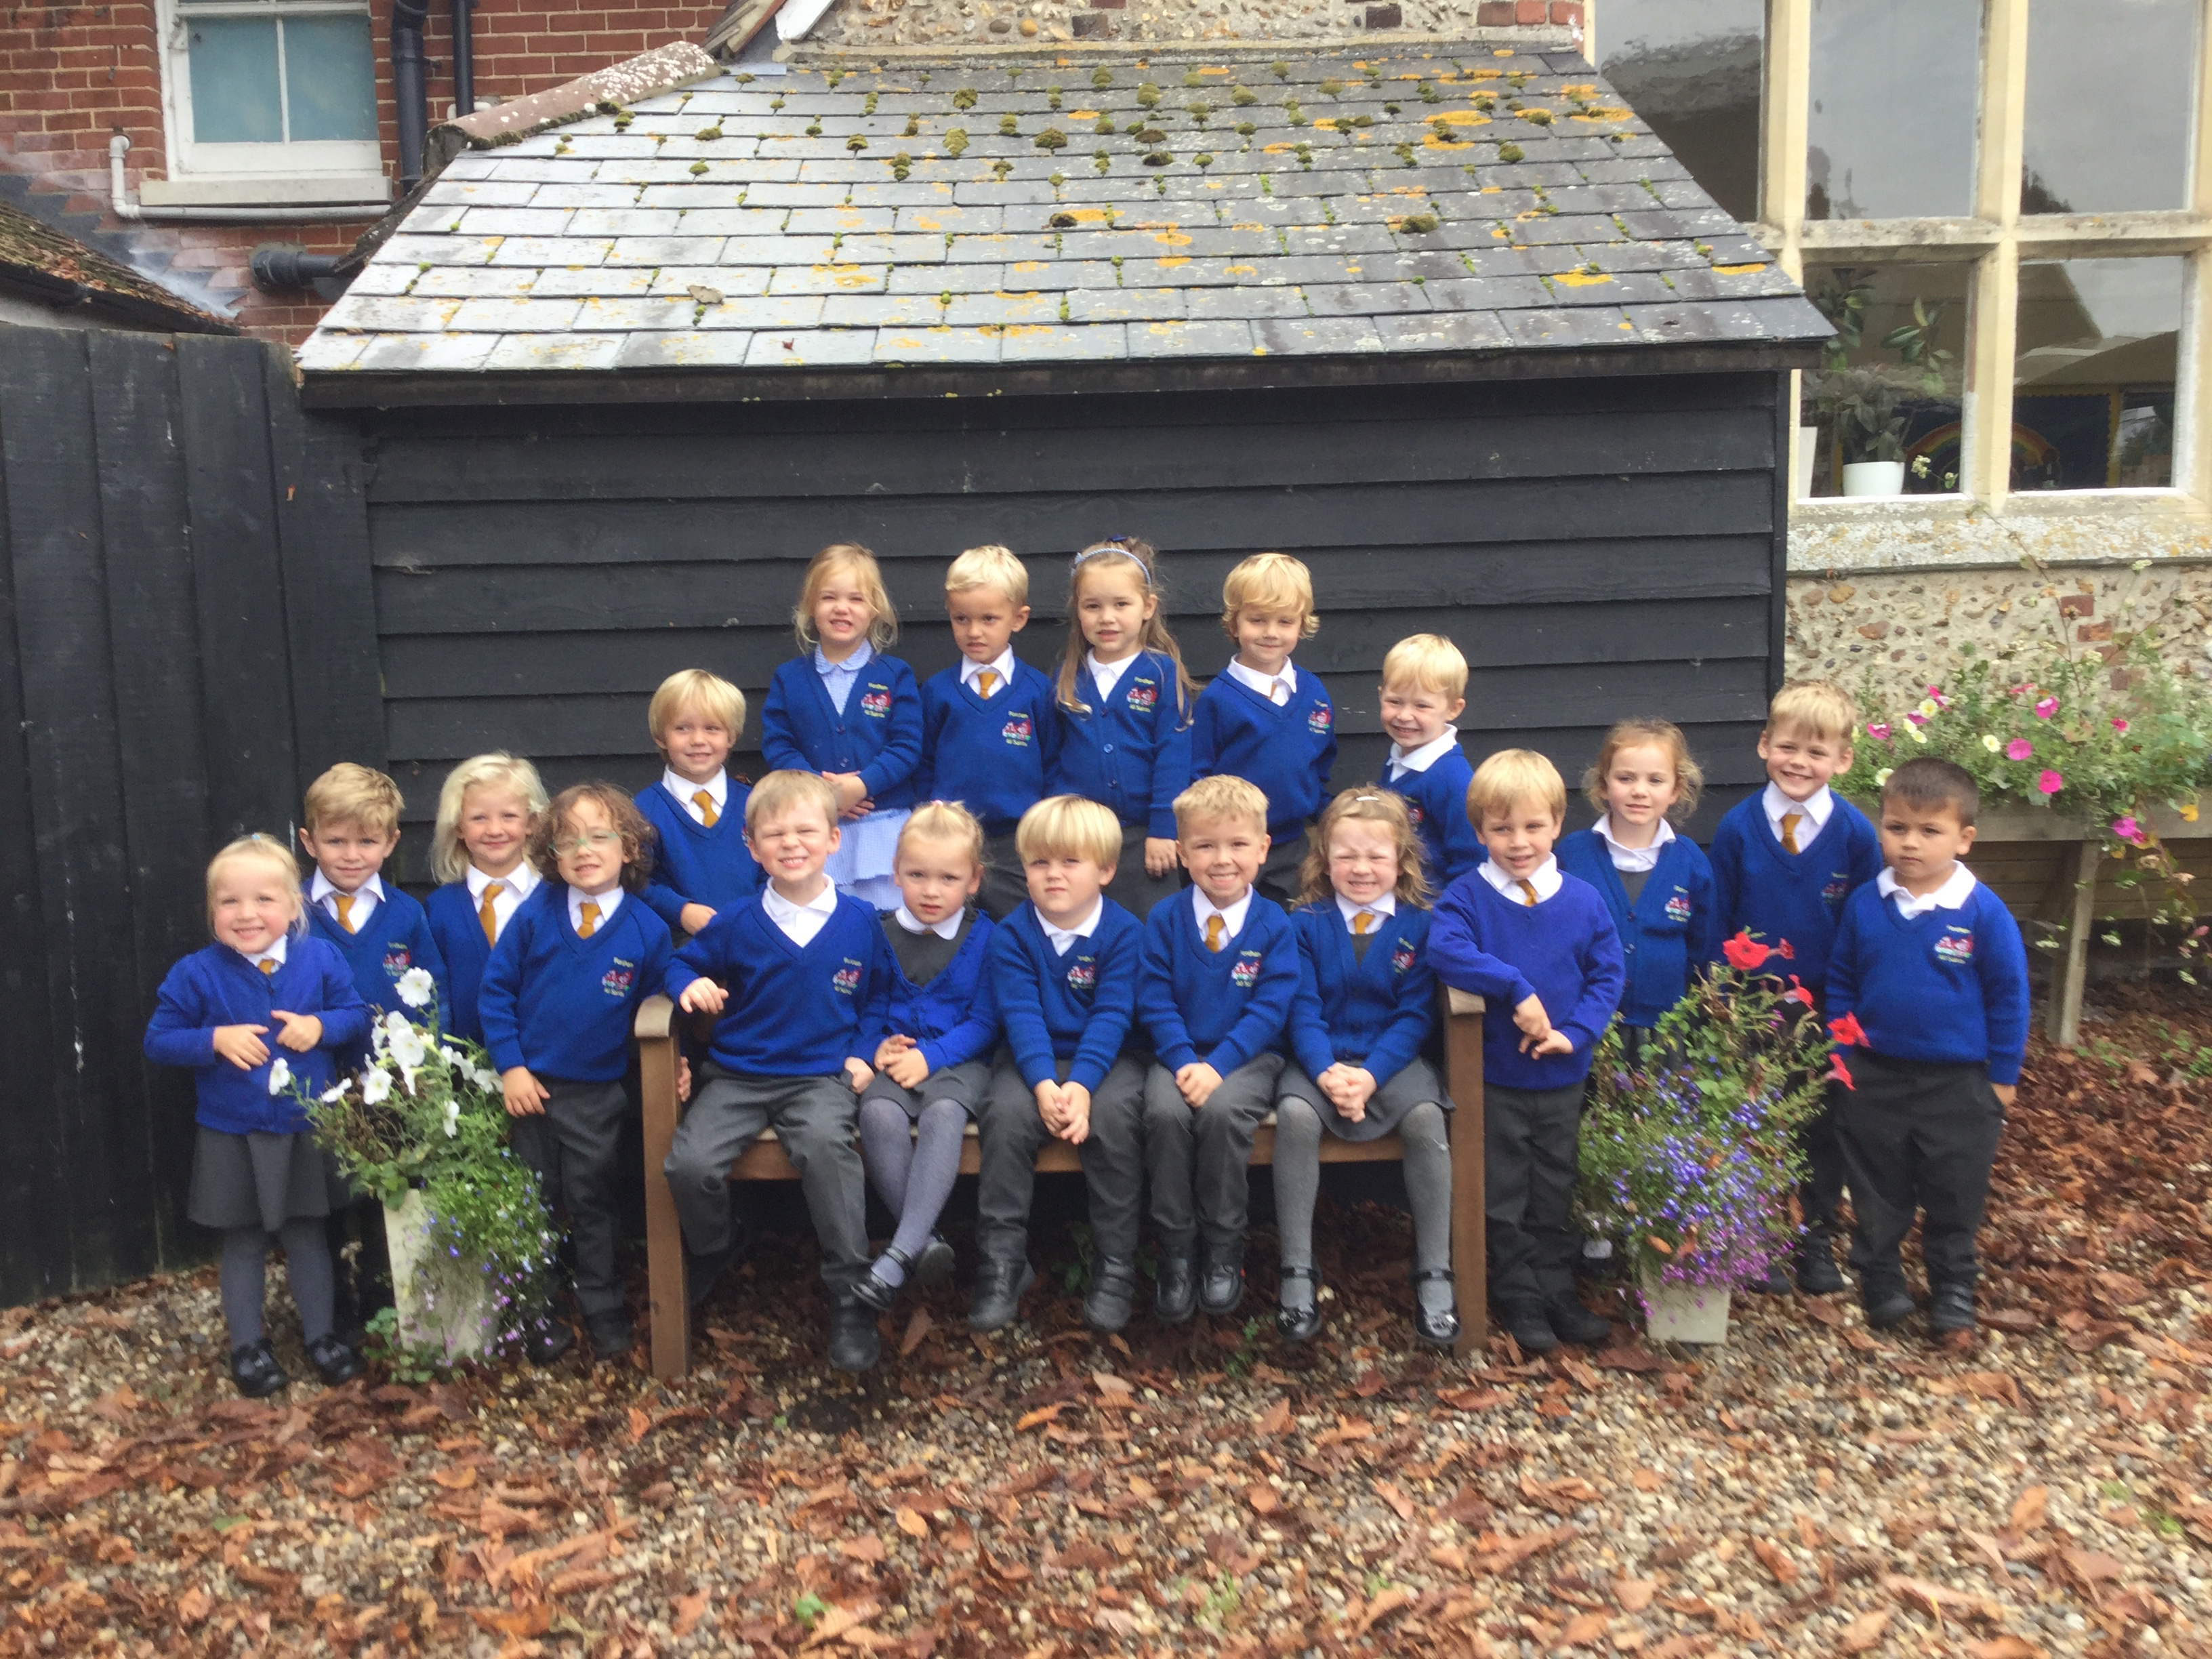

September seems to have come and gone in a flash! There have been lots of changes for everyone this year. We welcomed 20 wonderful new ‘Early years’ pupils into class 1 at the start of the term. These children have already proved themselves to be a great asset to the Fordham family and have all made a great start to their learning journey here in school. You may have spotted them in the paper this week in the new school starter supplement in the Gazette.

Well done to everyone for a great start to the year. I’ve seen some wonderful working this half term already with children engaging with the school’s termly theme of

‘Good Old London Town’.



**Gold Book Winners- September 2019**

**Class 1**- Dylan, Freddie, William. **Class 2**- Amelia, Frankie, Sophie C, Charlie G, Rose, Charlie W.

**Class 3**- Charlie R, Olivia N, Chase, Max, Aimee,. **Class 4-** William E, Paiten, Teddy, Barney, Harry T, Finn W

**Class 5-** Edward T, Fraser, Lacey- Fae, Eva, Archer, Hollie



**Responsibilities in school**

At the start of each year we give our children the opportunity to apply for several responsibilities around school. These responsibilities are applied for by the pupils in various ways. Our school responsibilities are….

House Captains- Year 6 pupils, 2 pupils from each House Team, have the opportunity to represent their peers as the House leaders. They have a major part in weekly Gold Book assemblies and are responsible for awarding House captain awards each week.

School Council- 2 pupils from each class to represent their class and take their views, opinions and questions to school council meetings. This is the opportunity for all pupils across the school to have a pupil voice in decisions.

Curriculum Ambassadors- We have curriculum ambassadors for Maths, English, Science and Worship. These pupils work with our teachers to ensure pupil voice is valued across the curriculum. They assist with curriculum days and subject leader time.

Sports Council- These children help to ensure school is active and purposeful. Helping Mr Askew in leading the curriculum area, providing pupil opinion and presenting assemblies on sports matters to the school. They also help with school sporting events.

Sibley Squad- Year 6 pupils chosen by Mrs Sibley to assist with the running and development of the school. These children organise weekly Gold Book assemblies, assist in school displays sand ideas, as well as representing school in open days.

Friendship Ambassadors- older pupils who assist with our younger members of school, ensuring they find a place to play, a friend or a game to join!

All of our children are easily recognisable in their roles by the presence of their representing school badges. These help pupils know who to go to help them when they need their pupil voice to be heard!

Pupil voice is a valued part of our school here and we know our children seek to gain these roles of importance at school.

A very big

THANK YOU!



Thank you to the Fordham Vehicle Show for donating £1500 of their proceeds

to us here at school! The money will be well used to provide curriculum days and new resources for our children over the year!

**LUNCH MENU**

**Please don’t forget to order all dinners in advance on the school meals system! We are trying hard to cut down on food waste and be kinder to the environment!**

Screen Shot 2017-06-09 at 13

HOUSE POINT WINNERS

This month’s winners have been……

Inspiration House

**DON’T FORGET!**

 Cake donations for this Thursday’s Harvest tea would be gratefully received! All donations to Mrs T in the school office on Thursday morning please!