A World of Difference

**English**

Narrative – Recovery Curriculum While we Can’t Hug Here we are

Stories in familiar settings The Huge Bag of Worries Changes Once Upon an Ordinary School

Grammar and Spelling activities related to year 2 and 3 objectives Handwriting practice Daily reading activities, including comprehension

**Science**

**Yr 2 –** *Materials* : Identifying ,comparing and investigating the suitability of everyday materials *Living Things:* Identifying habitats and how living things are suited to their habitat *Plants:* Observing plants and bulbs **Yr 3 –** *Plants:* Different parts, transport and growth *Animals including humans:* Nutrition, skeleton and muscles *Living things and habitats:* Nutrition, skeleton and muscles *Rocks:* Fossils

**Maths**

*Number: Place Value* Read and write numbers in numerals and words. Recognise place value of digits. Compare and order numbers Solve number problems

*Number: Addition and Subtraction*

Number bonds and related subtraction facts

Add and subtract numbers mentally and using formal, written methods

Solve addition and subtraction problems

‘Big’ Maths

Times Tables

**PE/Games**

Art Attack

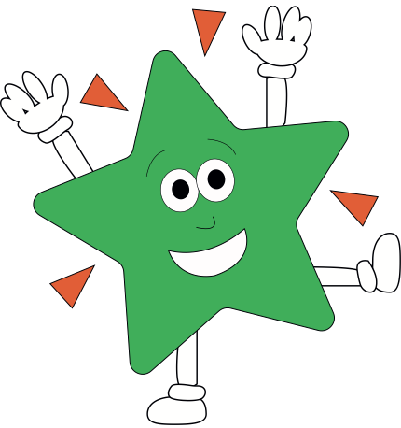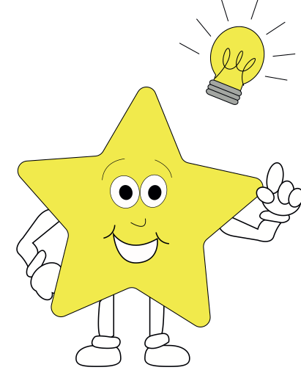

**Theme**

**Geography**  Naming the countries of the UK, their capital cities and surrounding oceans Naming and locating some counties and major cities of the UKUsing aerial pictures Rainforests Comparing weather in UK with hot country

**Art/DT** Painting - Seascapes Study work by artists including Monet, Rembrandt Renoir and Turner Create own pieces Drawing

**RE**- **God** What do Christians believe God is like? What is it like to follow God?

**PSHE** Recovery Curriculum Christian value - Friendship Keeping safe

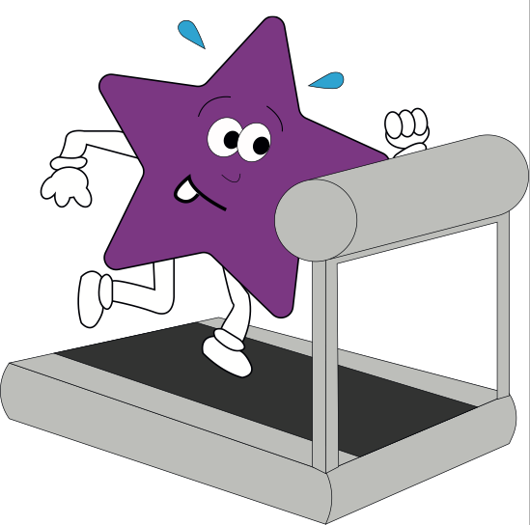

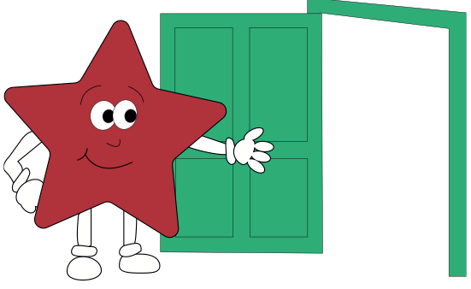

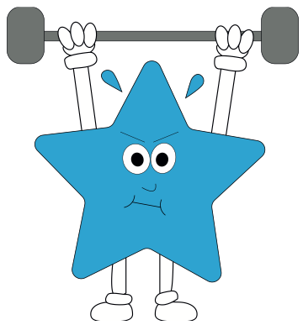

**Computing**  - E Safety

Password safety Share online video resources Search engines Writing and presenting ideas using Microsoft Word

**French**

Simple questions and answers, spoken phrases and simple conversations. New topic words.

**Music**

Sharing favourite songs and music and feelings experienced Composition using untuned instruments