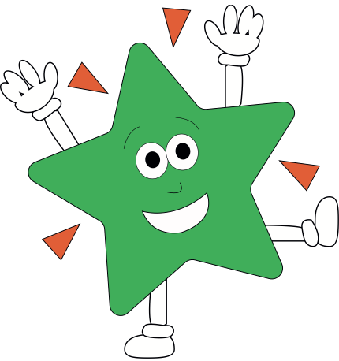A World of Difference

**English**

**The Little Shoemaker**

Following a small animation, pupils will look into skills for telling a traditional fairy tale, as well as applying grammatical devices they have learnt into fictional writing.

**Discussion Text**

Classroom courtroom will help us decide some of the ethical questions up for debate in fairy tales. Pupils will then attempt to write a balanced argument.

**Newspaper Article**

Revisiting newspaper writing from previous term, pupils will attempt journalistic writing for the Fairy Tale Times.

**Poetry**

Using Roald Dahl’s Revolting Rhymes, pupils retell their own ‘twisted’ fairy tale story.

Poetic study of Lewis Carroll’s ‘Jabberwocky’

**Explanation Text**

Pupils will research more about wolves and how they earnt their bad reputation in story books. Then, they will create an explanation text about them.

***Reading comprehension weekly in groups and as whole class.***

**Maths**

**Ratio (Yr 6)** – Ratio language, calculating ratio, using and calculating scale factors, ratio and proportion problems

**Decimals & %** – Understanding, rounding and ordering fractions up to 3DP, x and div decimals (including by powers of 10), converting FDP, finding % of amounts, adding & subtracting decimals, decimal sequences

**Algebra (Yr 6)** – Finding the rule, substitution, formulae, forming equations, finding pairs, enumerate possibilities

**Converting Units** – Kg/g, l/ml/, metric and imperial measures, time.

**Perimeter/Area/Volume** – Measure & calculate perimeter, measure & calculate area, formula for area, investigating volume

**PE/Games**

**Science**

**Year 6**

Revising Year 5 topics

Introduction to light, electricity, classification, evolution and the respiratory system

**Year 5**

Revising Year 4 topics

Introduction to life cycles, human lifespans, properties of materials, space and forces

Art Attack

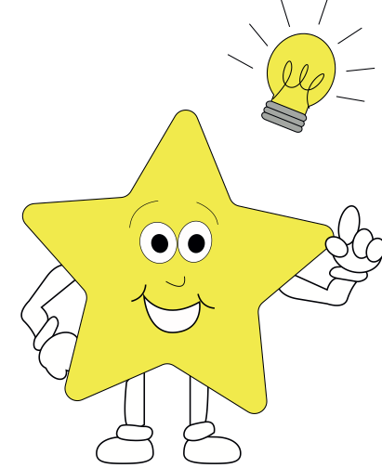

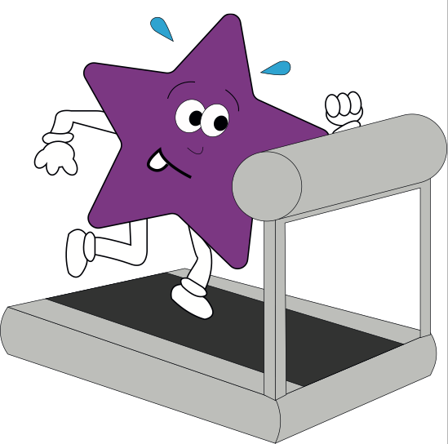

**Theme**

**History/ Geography**

History of famous Nursery Rhymes

Map making

**Art/DT/Music**

Shading techniques

Study of Monet – Haystacks & Lilies

Create a 3D Scene

Sewing a patchwork design

Music study of Peter and the Wolf

**PSHE**

Money Matters & Maintaining relationships

**RE**

Was Jesus the Messiah?

Important places in Islam

What did Jesus do to

save human beings?

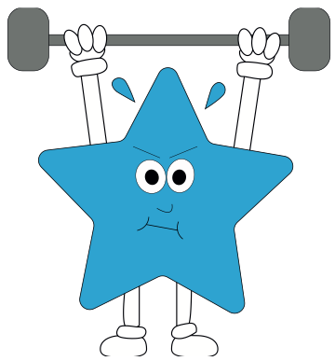



**French**

Food

Getting to know you

**Computing**

Esafety

Computer Game Design