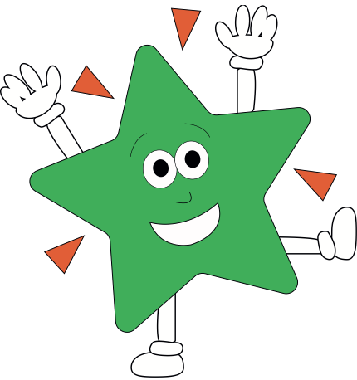A World of Difference

**Maths**Now that SATs is complete, maths will now take the form of a variety of problem solving and reasoning tasks relate to real world examples. We will do this in a variety of ways including games, drawings, puzzles, building and outdoor learning. We will continue to have maths meetings each week to maintain the recall for key facts learnt this year.

**English**Our main text type this half term will be imaginary world stories. During this unit we will look at various examples before creating our own imaginary worlds and forming stories around them. We will then conduct an author study of Roald Dahl whereby we will consider parts of his life as inspiration for his books.

**Science**Our focus this half term will be on materials. We will be exploring properties of materials, thermal and electrical conductors and insulators, separating mixtures and irreversible changes.

**PE/Games**

Art Attack

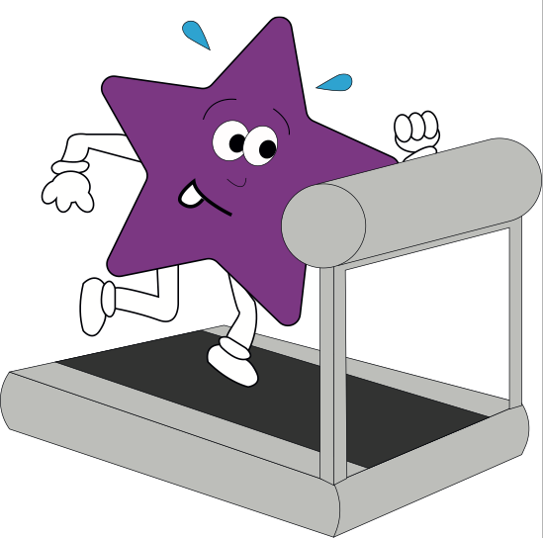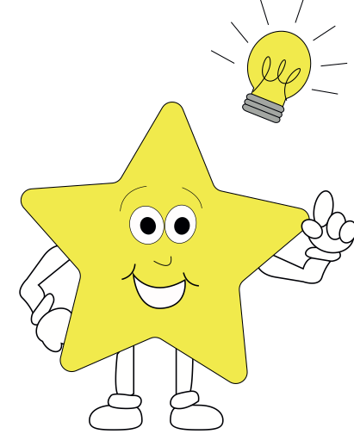

**Theme**

**Art:**We will be studying local architecture and how to draw in perspective. We will then draw and paint a representation of local buildings  
  
**History:**We will be studying the architecture of the local area how Colchester is so full of historical interest.

**RE**Our focus this half term will be solely on Humanism. This will include studying the humanistic view and beliefs, their symbols, the key thinker and how humanists would react in given situations.



**PE**  
EPC lessons will be focused on a mixture of athletics and striking games  
**French**Our French lessons this half term will focus on recapping key topics learned throughout KS2 such as food, family, animals, numbers, places and body parts.

**Pirates of the Curry Bean**Our school play will take up large amount of out afternoon lessons this term. It covers many objectives in areas such as drama, reading, speaking and listening and music.

