A World of Difference

**Science**  **Yr 2** *Plants* find out and describe how plants need water, light and a suitable temperature to grow and stay healthy.

*Living Things* describe how animals obtain their food from plants and other animals, using the idea of a simple food chain, and identify and name different sources of food.

*Animals* describe the importance for humans of exercise, eating the right amounts of different types of food, and hygiene.

**Yr 3 –**

**English**

Narrative Charlie and the Chocolate Factory – Creative writing activities relating to the text. Descriptive writing, including settings and characters

Grammar and Spelling activities related to year 2 and 3 objectives Handwriting practice Daily reading activities, including comprehension

**Maths**

*Fractions*

Make equal parts

Recognise and find a half

Recognise and find a quarter

Recognise and find a third

Unit and Non-unit fractions

Equivalence of a half and 2 quarters

Find 3 quarters

Count in fractions

*Multiplication and Division* Multiply 2 digits by 1 Divide 2 digits by 1

arithmetic skills

**PE/Games**

Art Attack

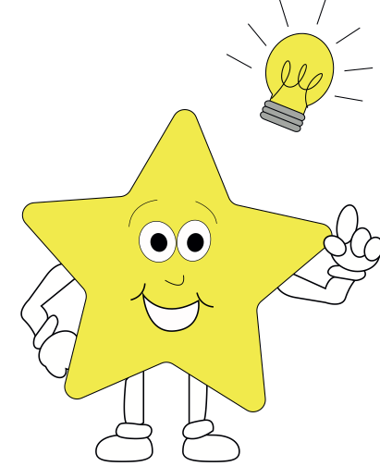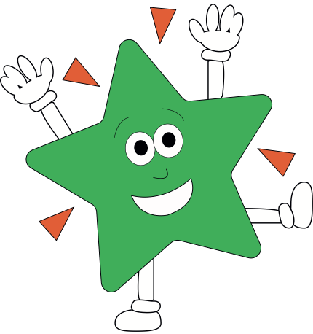

**Theme**

**Art/DT**

Designing a chocolate bar and packaging Painting - Colour mixing Drawing

Study of an artist

**RE**

Islam and Christianity – Comparing the Qur’an with the Bible

**PSHE** Christian value - Respect

**Computing**

Coding – writing codes to program an object to move, turn and to repeat commands.

**French**

Simple questions and answers, spoken phrases and simple conversations. New topic words.



**Music**

Repeating rhythms and

Recognising some simple music

notation and symbols.