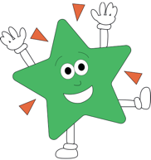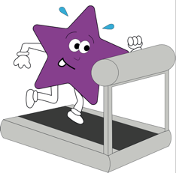

**Music**

We will be learning and singing nursery rhymes, chants and songs of different genres. We will explore different instruments and the sounds they make.

**RE**- Understanding Christianity. We will begin by looking at the creation story and thinking about what Christians think God is like.

**PSHE**- We will be learning about what makes a good friend as we settle into class 2 then we will be looking at what makes a healthy lifestyle.

**Theme**

**Geography-** we will be looking at the Arctic and comparing it to where we live (climate). We will be identify Fordham on a map and drawing our own maps of the village and labelling the different places. We will also be naming the world’s continents and oceans and identifying which continent we live in. We will be locating these on a world map.

**Art/DT-** This term will be focused around our theme and the children will be using different materials and textures to create artwork of arctic animals. The use of paint and mixing of colours will also be used to create our art work.

**English**

Daily phonics sessions (year 1)

Our English topic will begin with story writing. We will be learning the story of ‘Lost and Found’ by Oliver Jeffers through story mapping and actions then using this to strucutre our own stories. This links to our school theme of comapring where we live to a cold place. We will then be writing a non fiction fact file on an arctic animal. We will research our facts and learn the features of a non fiction text.

**Science**

Year 1s are learning about the human body,

and we will be learning the body parts through songs and practical activities. We will then move onto looking at materials and what materials different objects are made from. The children will be identifying properties of different materials and group these.

Year 2s are identifying, comparing and investigating materials and investigating the suitability of everyday materials. They will identify habitats and how living things are suited to their habitat.

**Maths**

Our maths learning will begin with number and place value (year 1- numbers to 10 and 20 and year 2- numbers to 100). The children will be counting forwards and backwards and will be learning to identify one more and one less than a number. We will then move onto recognising the place value of a number (tens and ones) and comparing and ordering numbers using < > and =. This will follow onto recognising money (coins and notes) and counting money. We will then start an addition and subtraction unit, exploring fact families and number bonds and then adding and subtracting numbers.

**Computing using Purple Mash**

We will be logging in and out of programmes and learning how to save work that we have done. During our research for our Arctic animal fact file, we will be using a search engine to find facts.

**French-** we will be learning French songs that help us learn the days of the week in French, the colours and numbers.