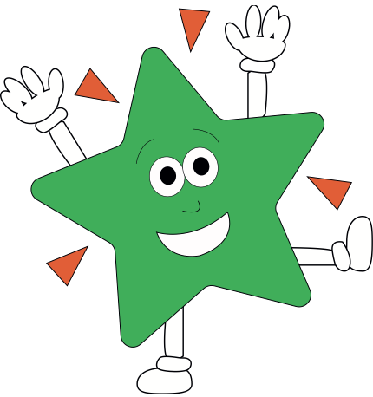A World of Difference

**Maths**The majority of this half term we will be working on place value. This will involve reading and writing numbers to 1 million, ordering numbers, finding missing numbers in a sequence, rounding, negative numbers and Roman Numerals. We may then move on to addition and subtractions before half term.

**English**Our first text type in English this half term will be Kensuke’s Kingdom by Michael Morpurgo. We will be reading through the book, getting into character and eventually writing our own story based on washing up on a deserted island and how we survive it! If you want your child to have their own copy in school, then please do.

**Science**These topics will be covered continuously throughout the year  
Year 4 – Living things and habitats. Year 4 are understanding more about classification for the first half term.  
Year 5 – Living things. Year 5 will be focussing on life cycles for the first half term.

**PE/Games**

Art Attack

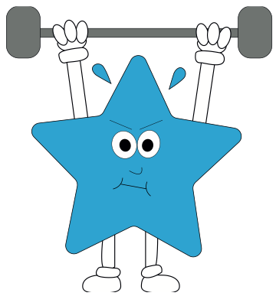

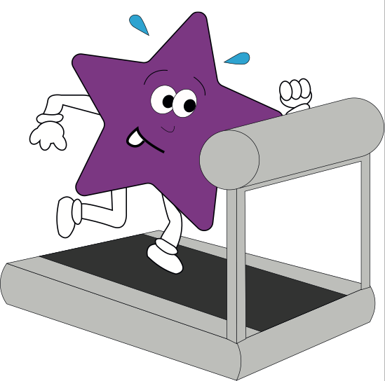

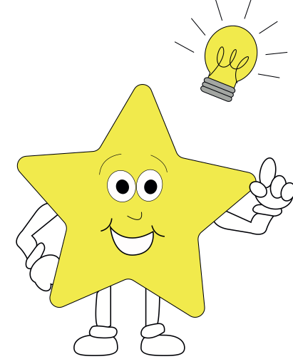

**RE**Our focus this half term will be Christianity. We will specifically be looking at what it is like to follow God. We will be looking at different characters from the old testament.

**Theme**

**Geography:**We will be looking at the Americas for our geography. Understanding the different features of these two huge continents.  
 **Art**Work based off artists from South America

**Computing**

Our computing unit will commence after half term. We will be looking at coding and using Scratch to help us understand algorithms!

**PE**The children will be competing in various ball games and activities **French**Children will be learning how to say the names of different countries and where they are in relation to the equator.

