
Imperative Verbs
Imperative verbs are also known as ‘bossy verbs’ because they tell people what to do! e.g. Shut the window. or Turn the kettle on.
imperative
verbs

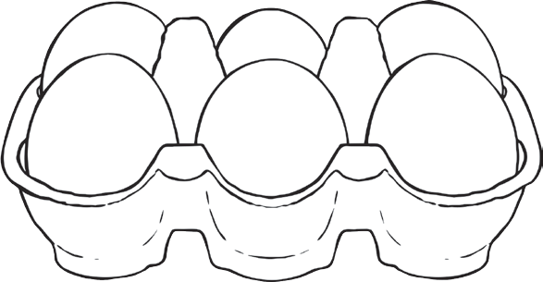


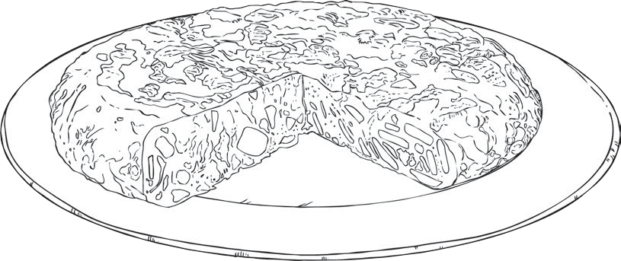
Imperative Verbs - Recipes
Choose the correct imperative verb to go with each instruction in this recipe to make a cheese omelette.
1.
2.
3.
4.
5.
6.
7.
and enjoy – your omelette is ready!
your pan until it’s nice and hot.
some eggs in a bowl and whisk.
together thoroughly.
some cheese and add to the egg mixture.
for a final two minutes until completely cooked.
your egg mixture and cook for three minutes.
Can you put the instructions in the right order to complete the recipe?
Firstly, . Secondly, . Thirdly, . After that, . Then, . Next, . Finally, .
visit twinkl.com
Page 3 of 3

Mix

Grill

Heat

Grate

Crack

Serve

Add

Colour in the words that could be used as imperative verbs.
Look at the sentences below. Can you think of some beginning to make an instruction?
that
could
go at the
1.
2.
3.
4.
5.
the door, there is a draught.
off the light please.
the milk into the glass.
on a coat before you go out.
left at the traffic lights.
?
visit twinkl.com
Page 1 of 2
Imperative verbs give instructions – they tell people what to do.
Can you think of a situation you might need to use an imperative verb?

shut

filthy

chair

turn

gold

lovely

mix

unhappy

close

stairs

Remember a verb is a doing word.

,

Page 1 of 1
Imperative Verbs Answers
Page 1
Colour in the words that could be used as imperative verbs.
shut, turn, mix and close
Can you think of some imperative verbs that could go at the beginning to make an instruction?
1.
2.
3.
4.
5.
Shut the door, there is a draught.
Turn off the light please.
Pour the milk into the glass.
Put on a coat before you go out. Turn left at the traffic lights.
Page 2
1.
2.
3.
4.
5.
6.
7.
Serve and enjoy – your omelette is ready!
Heat your pan until it’s nice and hot. Crack some eggs in a bowl and whisk. Mix together thoroughly.
Grate some cheese and add to the egg mixture.
Grill for a final two minutes until completely cooked.
Add your egg mixture and cook for three minutes.
Can you put the instructions in the right order to complete the recipe? Firstly, 3
Secondly, 2
Thirdly, 5
After that, 4
Then, 7
Next, 6
Finally, 1
visit twinkl.com

