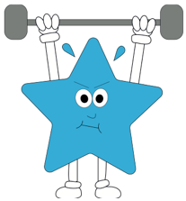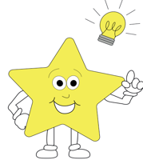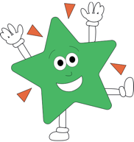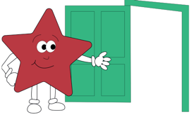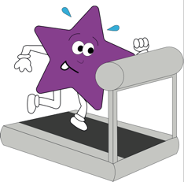

**Music**

We will be learning and singing nursery rhymes, chants and songs of different genres. We will explore different instruments and the sounds they make.

**RE**- We will be beginning to learn about Judaism and special Jewish stories and words.

**PSHE**- We will be learning about stranger danger, linking to our learning on Little Red Riding Hood. We will also be looking at our needs and responsibilities and how these are met.

**Theme**

**Geography-** We will be learning the 4 compass points, and using this to help us navigate around different fairytale land maps.

We will be looking at different types of buildings and settlements.

**Art/DT-** This term will be focused around our theme of Once Upon a Time. To link to our learning around Jack and the Beanstalk, we will be drawing plants and we will be doing our own versions of Van Gogh’s ‘Sunflower’ using pastels. We will be looking at what foods come from different plants and we will be making our own sandwiches to go in Little Red Riding Hood’s basket.

**Maths**

Our maths learning will begin with counting in 2s, 5s, 10s and 3s. Year 2s will then be learning their 2, 5 and 10 times tables. We will then be making, recognizing and adding equal groups. We then move onto arrays and multiplication. Year 2 will divide by 2, 5 and 10 and year 1 will move onto looking at place value for numbers to 100.

Tally graphs and pictograms will then be a focus.

**Computing using Purple Mash**

We will be making a ‘Wanted’ poster to help Little Red Riding Hood catch the wolf. We will be typing up a title and descriptions, as well as finding clipart images to put onto our wanted poster.

**French-** we will be learning French songs that help us learn the days of the week in French, the colours and numbers.

**English**

Daily phonics sessions take place.

Our English topic will begin with story writing. We will be learning the story of Little Red Riding Hood and creating our own stories based on the story of Little Red Riding Hood. We will also be writing a ‘wanted’ poster to help find the wolf and writing a letter to the wolf. We will then look at Jack and the Beanstalk to write a newspaper report about the Giant. We will also write a set of instructions on how to grow a plant as part of this unit of work.

**Science**

Year 1- We will start our science learning looking at seasonal changes from August to Winter. We will then move onto animals including humans and identifying mammals, bird, amphibians, fish a reptiles.

Year 2- Exploring and comparing the differences between thing that are living, dead and never been alive. Observing plants and bulbs. Investigating the factors affecting plant growth.