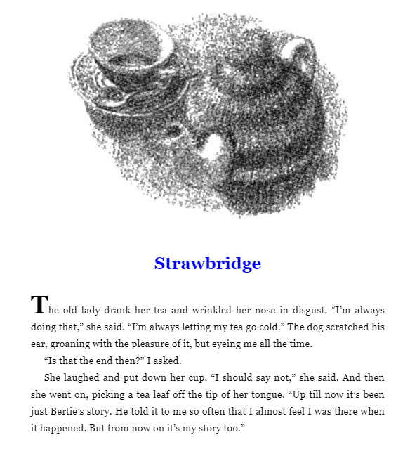

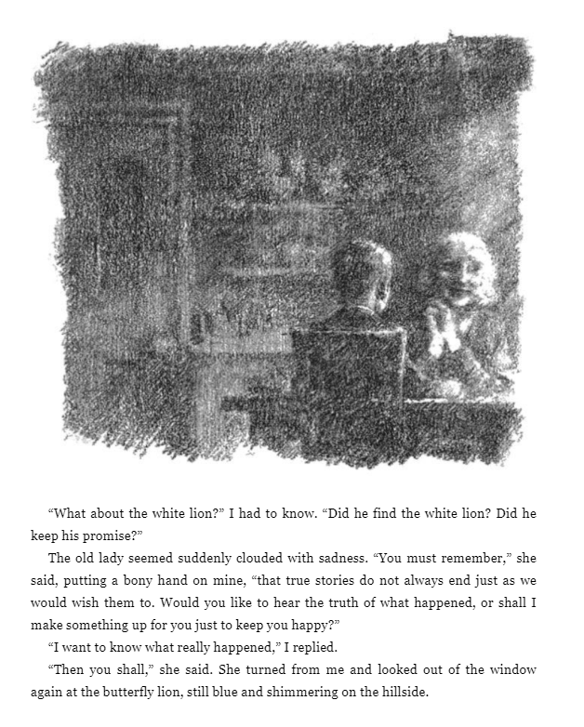

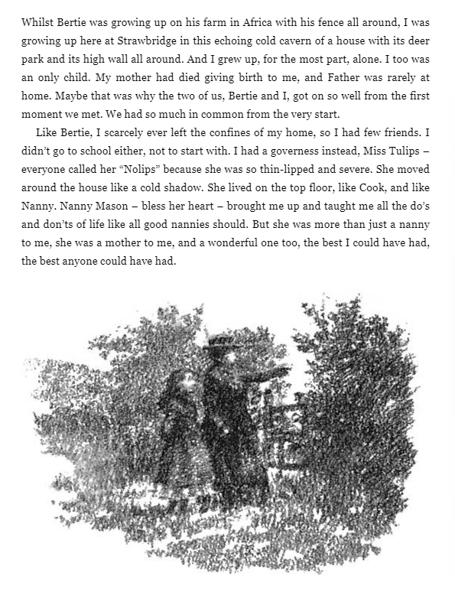

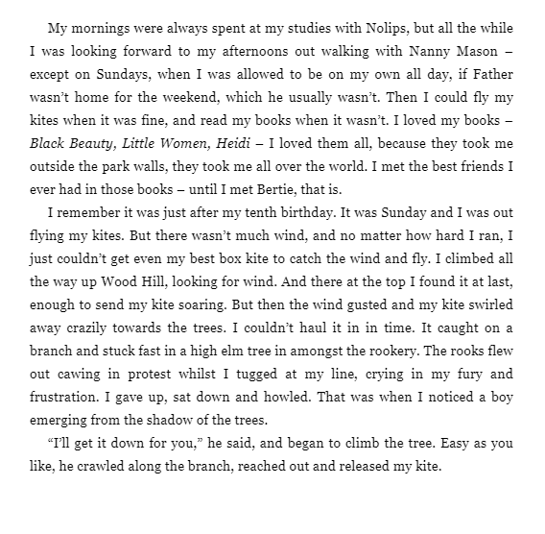

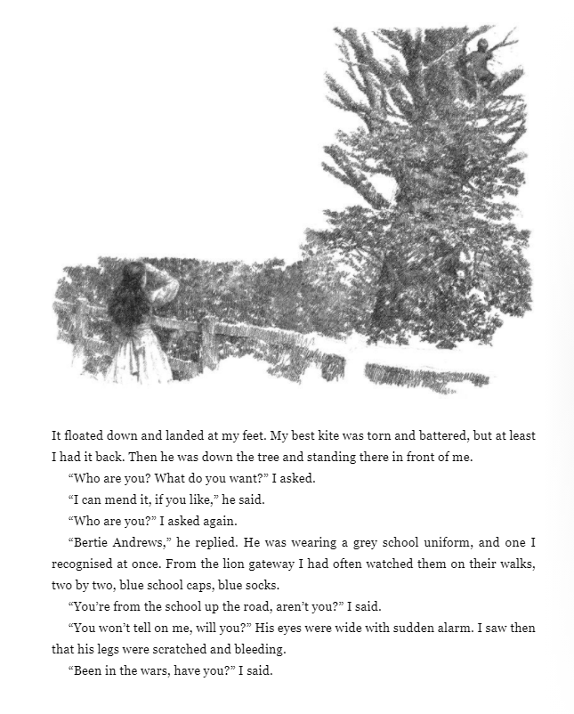

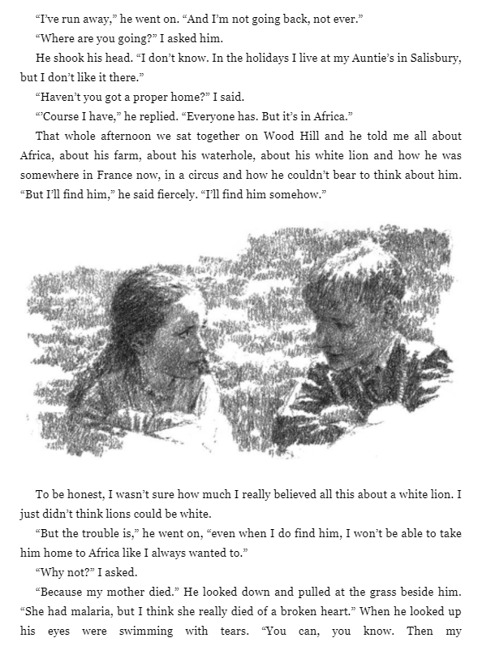

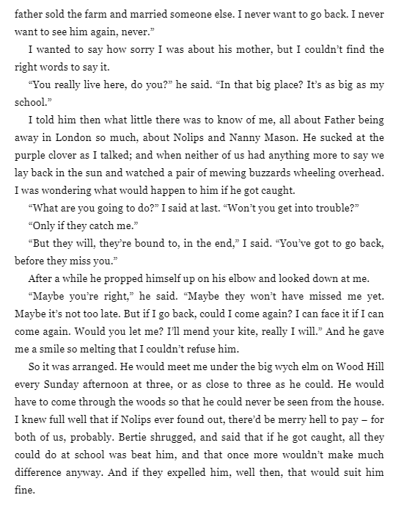

Work
- Why did the lady’s tea go cold at the beginning of the chapter?

- The lady offers the boy to tell him the truth or to give him a happy ending. Which one would you choose and why?

- Who is the boy that she meets?

- In what ways are Bertie and the first boy in the story similar to each other?

- Why does Bertie and the girl (The old lady when she is younger) make good friends?

