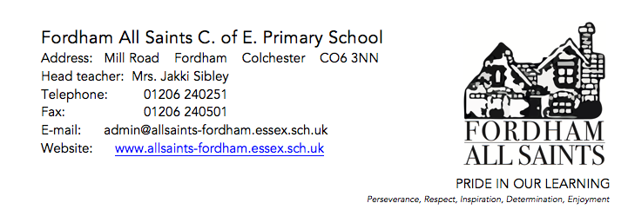

Dear Parents,

I wanted to explain the current situation in school with regards to the coronavirus outbreak.

We are continuing to follow advice from Public Health England in respect of Coronavirus. We have not been put on alert to close and at present we have no plans to close the school for any additional time. We are working closely with the Local Authority and if we are advised differently by Public Health England and the Department for Education to close, we will inform parents and carers immediately.

To support the delay of the spread of the virus, the Department for Health and Social Care has asked anyone who shows certain symptoms to stay at home for 7 days, regardless of whether they have travelled to affected areas. This means people should stay at home and avoid all but essential contact with others for 7 days from the point of displaying mild symptoms, to slow the spread of infection.
The symptoms are:
· A high temperature (37.8 degrees and above)
· A new, continuous cough

If your child develops any of these symptoms please ring us and let us know here at school. We will expect parents to follow the procedures as set out by the government and any children returning to school earlier than expected will be sent home.

As a small school it is likely that we will be hugely affected by staff absence. This may mean a change to the usual level of ‘service’ that you are used to. For example we may have to make class sizes temporarily different, staffing may need to change, and children who have key workers on a daily basis working 1:1 may temporarily be without this level of provision. If we face ourselves without kitchen staff, we may have to put measures in place for packed lunches only, and limited services. We will, of course, do everything that we can to avoid any changes, but I think we all have to be realistic and face what may be inevitable in the coming weeks.

In the event that I feel we are of an unsafe staffing level to keep school running, I will consult with my board of governors to make the decision to either close any affected classes, or to fully close the school for a period of time. This decision will not be taken lightly but will be done so with the interests of health and safety and our families in mind.

I will of course keep you fully updated. We currently have no suspected cases in school and appeal to you to follow the advise of the government and self isolate.

Wishing you all well,

Mrs Sibley
Head Teacher

