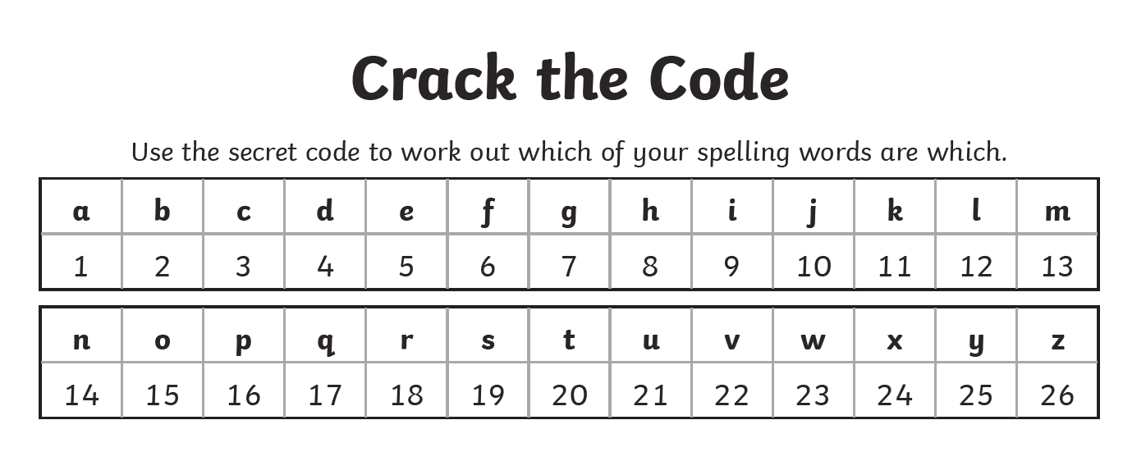
6 15 18 7 15 20 20 5 14 ______________________________________________

2 5 7 9 14 14 9 14 7 _______________________________________________

16 18 5 6 5 18 18 5 4 ______________________________________________

15 3 3 21 18 18 9 14 7 ________________________________________________

2 5 7 9 14 14 5 18 ______________________________________________

6 15 18 2 9 4 4 5 14 ___________________________________________

15 3 3 21 18 18 5 4 ____________________________________________

Which of your spellings have not been used? _______________________________________________
______________________________________________________________________________________
______________________________________________________________________________________

Can you write the codes for them?

