Year 6 Transition Learning Projects
WC 29.06.2020: Being a Problem Solver
This week’s learning project focuses on building your child’s ability to problem solve for their transition to secondary school. It will give them the opportunity to prepare for the different challenges they may face when they begin secondary school but also provide them with the skills on how to solve them. Each day, the children will be given a potential problem scenario (to which they should reply in the style of an ‘Agony Aunt’) a mindfulness activity and a challenge.
Potential Problem Scenarios | Challenges
Monday- As your child moves to Secondary School, they will be meeting and making new friends and will need to be able to solve any issues that they may face. “I’ve got two really good friends who don’t like each other. One keeps inviting me to things and leaving the other one out. It’s getting awkward and I don’t know what to do. Can you help me?’’ | Ask your child to carry out everyday activities without using their thumbs. Why don’t you take a picture of them completing the challenge or tweet them using #TheLearningProjects.
Tuesday- At Secondary School, your child may find their dining hall experience a lot different to that at Primary school. They will be in charge of monitoring the balance on their dinner cards and may feel anxious about the busy atmosphere.  “I got my hot dinner from the counter and realised I’d forgotten to put money on my dinner card. What should I do?” | Ask your child to use recycling items you have in your house to build a bridge. How will it be constructed? How are they going to make it strong and sturdy?
Wednesday- At Secondary School, your child will move to different classrooms throughout the day, work with different children and be taught by many teachers. What if they don’t get on with their peers or teachers? “My teacher has paired me with a child I don’t get on with, who expects me to do all the work for them. They are really popular and I’m worried if I say anything, I will get picked on. I also don’t want to get a bad grade. What should I do?’ | Ask your child to see if they can draw a picture of their dream house blindfolded. How accurate can they make it without looking.
Thursday- At Secondary School, the use of social media may become an increasing part of your child’s life. How can they ensure they stay safe and respectful online? “My friend added me to a group chat and there are some unkind comments about a child in my year group. I don’t want to get involved but I’m worried about the child. What should I do?” | With a partner, challenge your child to imitate a celebrity, book character or friend for the other person to guess.
Friday- When your child starts Secondary School, they may have to use a new mode of public transport or walk to school. What can they do to ensure they stay safe? “The friend I usually walk home with has gone home sick from school. I won’t have anyone to walk home with and am really worried about being by myself. What should I do?” | Choosing only 5 ingredients from the cupboards, challenge your child to create a tasty new dish or snack.
Additional Learning Resources Parents May Wish To Engage With:
- Possible solutions to the problem scenarios for this week
- Store cupboard recipes to help inspire the 5 ingredient dish challenge
- Relaxation activities
- Child Line Toolbox
- Activity to help pupils feel connected to their friends
#TheLearningProjects

Year 6 Transition Learning Projects
WC 29.06.2020: Being a Problem Solver - Example Work
Below are some examples of how your child could set out their work.
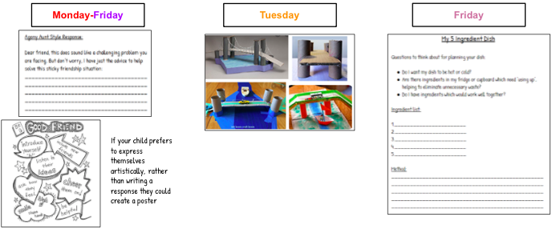
#TheLearningProjects

