Home Learning for Class 3 w.c. 1st February

 | Mon | Tues | Weds | Thurs | Fri
Maths | Statistics  Year 2  Make Tally Charts  https://vimeo.com/501669795  Watch the video and do the activities as you go through it.  No worksheet today  Year 3  Interpret Pictograms  https://vimeo.com/500378019  Watch the video and complete as much of the worksheet as you can.  TT Rock Stars 5mins | Year 2  Make Tally Charts  https://vimeo.com/501671369  Watch the video and complete as much of the worksheet as you can.  Year 3  Draw Bar Charts  https://vimeo.com/501677687  Watch the video and do the activities as you go through it.  No worksheet today  TT Rock Stars 5mins | Year 2  Draw Pictograms  https://vimeo.com/501673699  Watch the video and complete as much of the worksheet as you can.  Year 3  Bar Charts  https://vimeo.com/502337848  Watch the video and complete as much of the worksheet as you can.  TT Rock Stars 5mins | Year 2  Interpret Pictograms  https://vimeo.com/501674074  Watch the video and complete as much of the worksheet as you can.  Year 3  Tables  https://vimeo.com/502338566  Watch the video and complete as much of the worksheet as you can.  TT Rock Stars 5mins | Year 2  Block Diagrams  https://vimeo.com/504485413  Watch the video and complete as much of the worksheet as you can.  Year 3  Statistics assessment  Complete the assessment to see how confident you are with statistics.  TT Rock Stars 5mins
English | Writing a Diary  This week I would like you to write a personal diary.  You could upload your entries each day or at the end of the week.  You could make a little book with a lovely front cover or simply write your entries in your writing books or on paper.  Watch/read through the powerpoint to help you.  Reading Time 15-20mins | Continue with your diary.  Reading Time 15-20mins | Continue with your diary.  Reading Time 15-20mins | Continue with your diary.  Practise your spellings.  Reading Time 15-20mins | Finish your diary.  Reading Time 15-20mins
Other | History  The Great Fire of London  https://www.bbc.co.uk/newsround/37222884  Can you find out the answers to these questions?  Remember to write your answers in complete sentences.  When was the Great Fire of London?  What was London like at this time?  How did the fire start?  How many buildings were destroyed?  How many deaths were recorded?  How was the fire stopped? | Science  Year 2  What do plants need to grow?  https://www.bbc.co.uk/bitesize/clips/zcn9j6f  Can you create an information poster to show what a plant needs to grow well?  Year 3  How is paper made?  https://classroom.thenational.academy/lessons/how-is-paper-made-68t38r | PE – Some suggestions to keep you active.  https://www.nhs.uk/10-minute-shake-up/shake-ups  https://www.bbc.co.uk/teach/supermovers  https://www.getset.co.uk/tokyo-ten | French  Numbers 1-20  https://www.youtube.com/watch?v=8hK4Leo2rTI  Can you learn this song to join in with?  How many numbers can you remember? | Computing/Art  Creating Pictures: 2Paint a Picture.  We are going to learn about 2 different artists this week – Mondrian and William Morris.  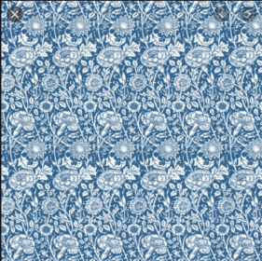  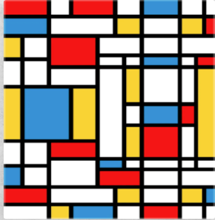  Firstly, I want you to research the two artists, (I have also included some of their work) and look at some of their famous painting.  Have a go at painting a picture of your choice in each style, using the Lines option for Mondrian and Pattern for William Morris. Hand your favourite in for me to see please.

