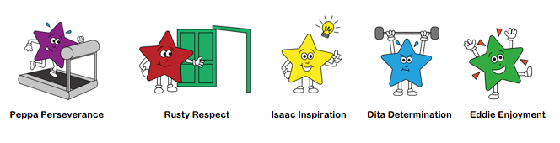

Home Learning
Useful websites: Nearly all are offering free access for homelearning

Reading –OXFORD OWL Ebookshttps://www.oxfordowl.co.uk/for-home/find-a-book/library-page/ Please try to share a book daily – this could be a levelled book or a book for pleasure.
https://libraries.essex.gov.uk/e-books-e-audio-e-magazines-and-book-groups/e-books-and-e-audio/
Phonics:
https://www.animaphonics.com/
https://www.phonicsplay.co.uk/

Physical Development
https://cosmickids.com/
https://www.bbc.co.uk/programmes/p06tmmvz (Andy’s wild workouts)
https://www.channel5.com/show/milkshake-bop-box-boogie/

General:
Purplemash –Activities for all subjects available on Purplemash – over the coming weeks there will be activities linked to Purplemash. You will already have your child’s log in, but if there’s any problems I can resend this information.
https://www.twinkl.co.uk/resources/covid19-school-closures
https://abcdoes.com/home-learning/

Please upload any learning to your child’s Tapestry page daily.
Little Daily Tasks:
- What day is it today? What day was it yesterday? What day is it tomorrow? You could have the days of the week (Monday to Sunday) on display.
- Try to share a book, this could be a book that the adult reads, or a levelled scheme book. Discuss the pictures, who is in the story? (characters), where does the story take place? (setting) and what is happening? (Up to 10 mins) This could be your bedtime book too.
- In Class 1 we have a feelings chart. Every morning (and throughout if their feelings change) pupils place their photo onto one of coloured feeling jar pictures. We like to talk about our feelings, discussing why we may feel that way and how we can help one another.
- Don’t forget to practise putting shoes on and doing up zips independently too.

PHONICS: Up to 15 mins
 | Group 1 | Group 2
Monday | Read Phase 2 letters, quick-as-a-flash –  REVIEW ‘W’  Recap the letter sound and action for ‘w’  Play the Rolling dice game for w‘’ (see attached).  Using letter cards/magnets can you make the words: wet, well, wig, will. Win Say the word, segment it and then spell it.  Spread the letters on the floor and jump to pick them up – make it a fun game.  Lastly practise reading Rainbow words as-quick-as-a-flash. (flash cards or stick words on wall and splat them/tap with wand). | Read all letters learnt so far as-quick-as-a-flash  Review ‘oa’ sound and action  Play colour in real and nonsense (alien) ‘oa’ words (see attached).  Choose an ‘oa’ word and write ONE sentence.  E.G I can see a goat on the farm.  I can see a foal on the farm.  I wash my hands with soap.  Lastly practise reading Rainbow words as-quick-as-a-flash. (flash cards or stick words on wall and splat them/tap with wand).
Tuesday | Read Phase 2/those new phase 3 as-quick-as-a-flash.  Look at phase 3, lesson ‘X’ on animaphonics.  Read the sound and do the action, adult to read the story.  On the next page, read the words and blend them together.  Follow the buzzy bee and write the letter, first with your finger and then on (paper, book, chalkboard, whiteboard, in flour or sand tray)  Look at the reading page. Talk about the picture and read the caption.  Using letters (cards/magnets), make a couple of words from the caption sheet, adult to say word, child segment word and child makes it.  Rainbow words as-quick-as-a-flash. | Read all letters learnt so far as-quick-as-a-flash  Look at phase 3, lesson ‘or’ on animaphonics.  Read the sound and do the action, adult to read the story.  On the next page, read the words and blend them together.  Follow the buzzy bee and write the letter, first with your finger and then on (paper, book, chalkboard, whiteboard, in flour or sand tray)  Look at the reading page. Talk about the picture and read the caption.  Using letters (cards/magnets), make a couple of words from the caption sheet, adult to say word, child segment word and child makes it. Can you read the caption, hide the caption and write the caption?  Rainbow words as-quick-as-a-flash.
Wednesday | Read all letters, quick-as-a-flash –  Recap the letter sound and action for ‘X’  Play a game on PHONICS PLAY (Phase 3, set 6)  Outside (if possible) adult say a word and child writes it with brush and water.  Real Words: box mix fox  fake alien words: , zox, mox  Rainbow words as-quick-as-a-flash. | Read all letters, quick-as-a-flash –  Recap the letter sound and action for ‘or’  Play a game on PHONICS PLAY (Phase 3, set 9)  Outside (if possible) adult say a word and child writes it with brush and water.  Real words: fork, short, cork, port, sort, York  Fake alien words: zort, mort,  Rainbow words as-quick-as-a-flash.
Thursday | Recap all letters as-quick-as-a-flash  Teach ‘y’  Follow Animphonics lesson for ‘y’  Once completed use letters/magnets or write the following words; yak, yes, yet, yap, yell  Read Rainbow words. | Recap all letters as-quick-as-a-flash  Teach ‘oo’  Follow Animphonics lesson for ‘oo’  Once completed use letters/magnets or write some of the ‘oo’ words. Adult to say the word first. Can you read, cover and write the caption for ‘oo’.  Read Rainbow words.
Friday | Read all letters, quick-as-a-flash –  Recap the letter sound and action for ‘y’  Outside/inside  Play hopscotch by reading a word and jumping on it.  Yet, box, yes, yak, fix  Animaphonics spellingsheet  Rainbow words as-quick-as-a-flash. | Read all letters, quick-as-a-flash –  Recap the letter sound and action for ‘oo’  Outside/inside  Adult to lay out/chalk down some words that contain ‘oo’. Child to read the word and jump on it.  Choose an ‘oo’ activity (under the ‘oo’ lesson on Animaphonics – wiggly wig, matching words, etc  You could write one short sentence using ‘oo’  E.G I have a hood on my coat.  Rainbow words as-quick-as-a-flash.

Dough Disco/Handwriting 5-10 mins every day
MINI STICK LETTERS

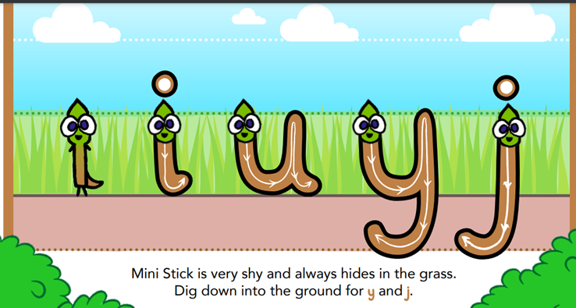
(Large versions found under, display and letter bug letters on Animaphonics)

Always start with some music and a ball of dough. Follow the actions; squeeze dough, ball dough, pat dough, pinch dough and roll dough into a sausage. (a few minutes)

Focus on ONE letter every day. Say the letter, follow the formation of the letter with your finger and lastly write the letter – you can vary how you write it every day by using; pen, pencil, paint brush, chalk, crayon or in a sand/flour tray.

Maths Focus: Number (up to 20/25 mins)
Activity 1 | Sing and dance along to the rhyme ‘ten in the bed.’  Next place ten counters on a tens frame and every time a bear falls out the bed, take a counter off. When there’s none left, discuss how nothing is zero. What does a zero look like?  Watch numberblocks video for zero.  Next lay numbers 0-10 on the table. Encourage the children to represent numbers including 0 Show me 3 fingers, show me 5, show me 0 Show me 4 apples in the basket, show me 2, show me 0 Show me 4 claps, 1 clap, 0 claps.
Activity 2 | Polar bear song with frame. Sing the song and take a counter away each time. https://www.twinkl.co.uk/resource/t-t-2547015-five-little-polar-bears-rhyme-song-powerpoint  Place numerals in a bag (up to 10 or more if needed) ask your child to take a number out, say what it is and then complete a task, E.G jump 5 times, hop 10 times, etc.  Next, in the garden set up a game that encourages them to throw objects into a bucket, using a chalk can they draw lines for every object they get in the bucket. What number did they get?
Activity 3 | Sing the counting to ten song: https://www.youtube.com/watch?v=HkkYaj0m6cg  Next adult and child to each make a tower. Which tower is the tallest? Hpw many in each tower? Which has more/less?  Next place some dominos in a bag, ask your child to take one out. Which side has more/less?  Next turn a pack of number cards over (up to 10 or more) child choose a card, turns it over and then counts out the same number using objects. Next count out more or less then a chosen number.
Activity 4 | Counting to 10 song: https://www.youtube.com/watch?v=85M1yxIcHpw&list= PL9upehN5QqdEu_RBWE9PAgFUpnYyGQEIs&index=12  Next take 5 counters/objects and explore the different ways that 5 can be made- E.G 2 and 3, 4 and 1, etc. Do they need to count the amounts or say by just looking? (could try for 10)  Use the attached sheet (ladybirds/stars) to draw the different ways that 5 can be made. (could try for 10)  Play a hiding game, show 5 objects, child closes eyes, place some under cloth and have some on show. Next child opens eyes and says how many they think are hiding.  (You may want to try this for 10 objects).
Literacy/Theme: This week our book focus will be ‘Poles Apart’ by Jeanne Willis and Jarvis. Watch Mrs Lawrence read the story. What has happened to the penguins in the story? How does the polar bear help them?
Pick one/two activities every day from below (at least 10 mins for each activity)

Cutting skills/Fine motor activity  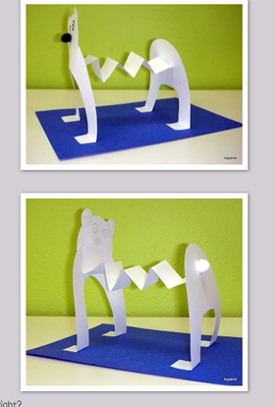  Cut the front and back from card (cereal box or white card if you have it). The tail could be cotton wool. Cut a long paper strip and fold back/forth like a concertina. Draw the nose, eyes and mouth. Have fun. | Communication and language  Question of the week  Look at photos of Polar bears and where they live. Why are polar bears white? Is there anything interesting about their fur??
Literacy/Physical Development
Using shaving foam (or similar) in tray use your finger or hold a pencil to mark make lots of patterns and shapes (zig-zag, waves, circles, lines, etc)
Next can you write some words from the story?
Boat, hat, Pog, fun, wet, bus…. Say the word, segment it and write it. Keep it fun!
Technology Activity:  Log into Purple mash and explore maths/phonics games. | Physical Activity (to be done on different days)  - https://www.youtube.com/watch ?v=DP9jd1Ug2y4  Cosmic Kids Yoga Polar Bears  - https://www.my5.tv/milkshake- bop-box/season-2/it-s-cold  - CHALLENGE: At the end of the story the penguins floated away in a basket with balloons. Ask an adult to blow up a balloon, can you keep the balloon up in the air for the count of 20?
Literacy Activity
Discuss what may have been in the penguin’s picnic?
If you went on an adventure what would you pack in your picnic?

Print off the picnic basket, write your name label. Next cut out and label(see attached), or draw and label
IDEA: On another day, you could make a ‘living room den’ and have your snack/lunch in it.
Literacy activity
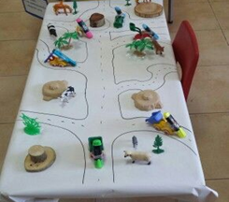
Using old wallpaper, a flat cardboard box. Can you create something similar below to show the journey that they took in the ‘Poles Apart’ story. Can you write labels for the countries, sea, north pole, south pole, can you use blue, white fabric, flannels or other resources to show the sea, arctic/antarctic?? Can you use construction to show buildings in the countries they visitied? This can be as small or large a project as you want. If they can sound out the words to write them, it doesn’t matter if the labels are misspelt, which letters can they hear in the words? Can they hear the first letter?? Talk about capital letters too.

Expressive Arts and Design activity: Arctic/Antarctic
Do you remember where the penguin/polar bear live in the story?
If you can’t remember, then listen to this fun rap all about the Arctic/Antarctic?
https://www.bbc.co.uk/teach/bring-the-noise/andys-raps-polar-party/zn9fmfr/
Discuss how both places are the coldest on earth.
Which is colder? Which has more animals living there?

Chalk a large picture of the world in the garden or paint/colour it t on a paper plate/paper circle and use cotton wool(soft, white fabric) to show where the Arctic and Antarctic are. Could you cut out little Arctic/Antarctic animals and stick where they live too?
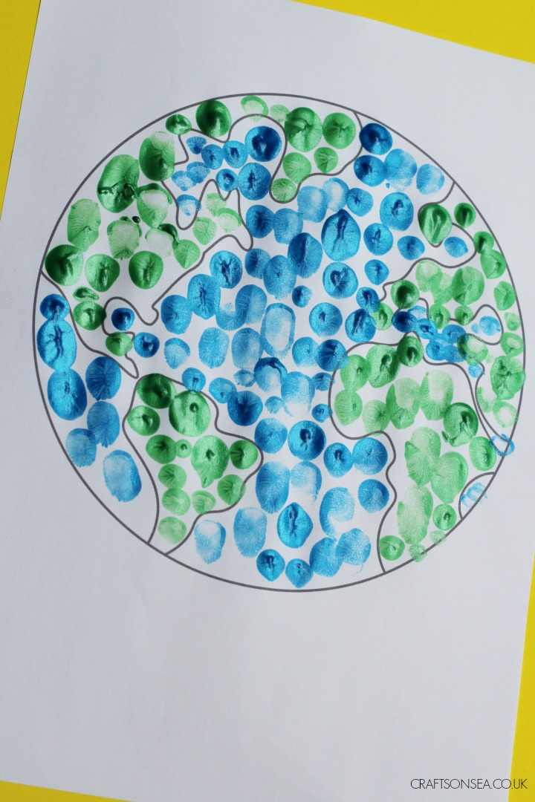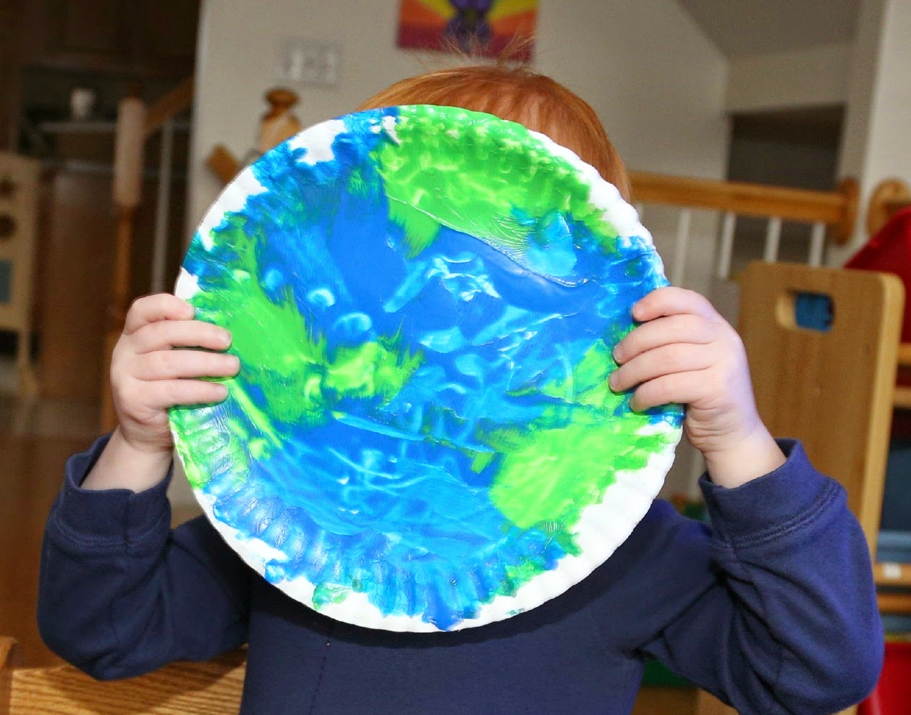

Travelling Tuesday: a country of your choice – based on your grocery supplies and resources at home.  Where is the country? What does the flag look like? Can you look at photos? What food do they eat? How do they say “hello”? What animals are from this country?  You could choose a country from the story; America, Australia, Italy or India. | Understanding the world, health and self-care.  Can you make fairy cakes or round biscuits (depending on ingredients).  Discuss washing hands beforehand. Talk about the ingredients. What equipment will you use? What happens first? Next? What happens after it is cooked? Are the ingredients still soft, runny? Can you decorate with white icing and food items for eyes, ears, nose and mouth.  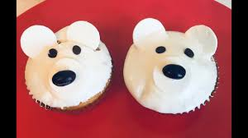  https://www.bbcgoodfood.com/recipes/iced-fairy-cakes or  https://recipes.sainsburys.co.uk/recipes/baking/easy-biscuits
Turn-taking/feelings
Play a board game – a good focus for turn taking and playing for enjoyment.

https://www.bbc.co.uk/iplayer/episode /m000h3yb/love-monster-series-1-18-happy-to-help-day
Watch the ‘Happy’ episode of Cbeebies ‘Love Monster’. What makes him happy? What makes you happy? How does it feel when you’re happy?

