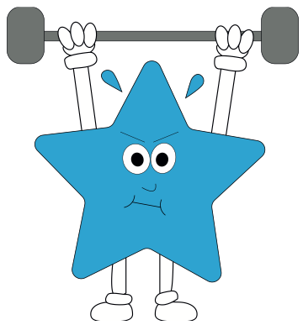A World of Difference

In Maths this term, we will continue to focus on times tables and practise them regularly in school with Times Table Rockstars on paper. The home learning expectation of children practising regularly on their times table rockstar accounts remains the same.

In other areas of maths we will be consolidating our understanding of

- multiplication

- division

- adding and subtracting fractions

And our new learning this half term will be:

- decimal notation for tenths

-(Year 4) place value of decimal numbers

- (Year 4) dividing by 10 and 100

- money and solving problems with money

- telling the time to the nearest minute, on a 12 and 24 hour clock

- (Year 4) converting between digital and analogue times

In English, both our units will be themed with our topics, the Anglo-Saxons.

To begin, we will be practising our narrative writing skills using the Anglo-Saxon myth, Beowulf. We will be looking at the characters, working on our descriptive writing and then using the structure to write a myth.

Following our trip to Sutton Hoo, we will be using the information gathered there and in our history learning to write a non-chronological report. We shall be focusing on using organisational features and paragraphs to organise similar information.

In Science, we will be learning about light.

We will be learning about:

- light sources

- how light travels

- properties of different materials and how much light they allow through

- shadows and how these are formed

- conducting simple experiments with shadows and lights

**PE/Games**

Art Attack

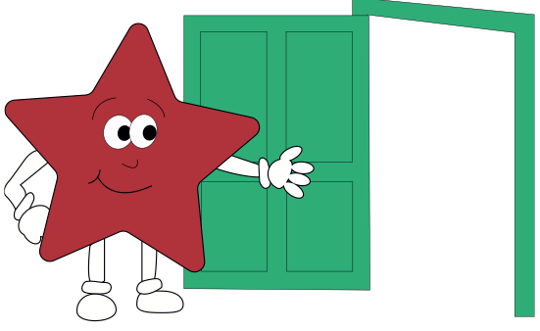

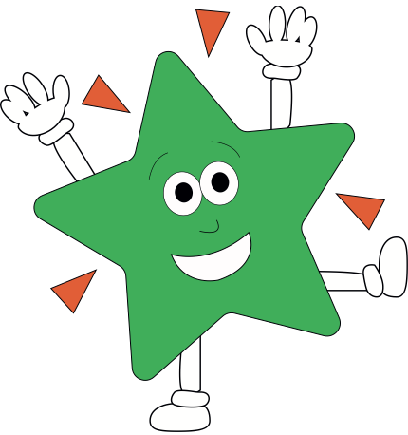

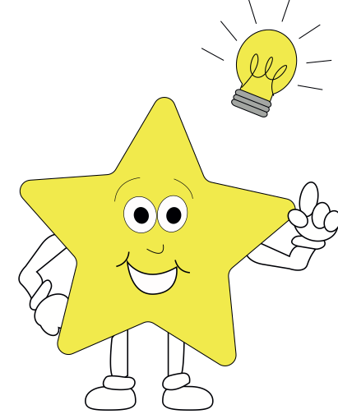

In **RE,** children will be studying Islam and the Qu’ran

In **PSHE,** children will follow the Jigsaw unit ‘Relationships.’

In **Music**, children will play and perform, using Charanga.

In **History,** children will learn about the Anglo Saxons. A lot of our learning will focus around our school trip to Sutton Hoo.

In **Art**, children will use a range of materials to create illuminated letters, replicating those from Anglo Saxon times.

In **D&T**, children shall be designing and making an Anglo Saxon shield.

In **Computing**, children will apply their skills using search engines to support and further their historical understanding.

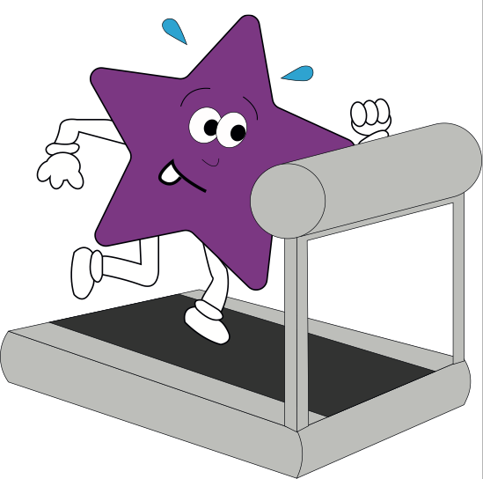

In **French,** children will continue to learn vocabulary to talk about their family. WE will also be learning about vocabulary to talk about features of our school.