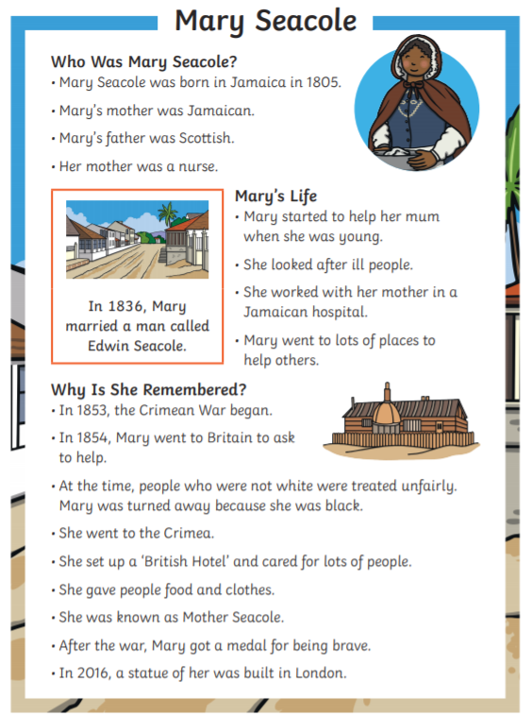
Reading Comprehension – Year 2
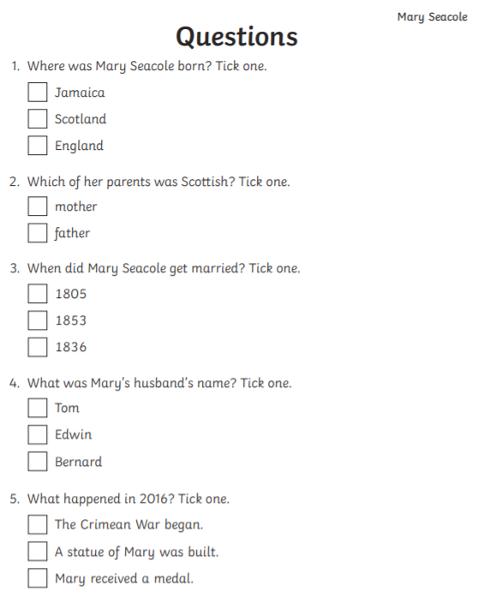

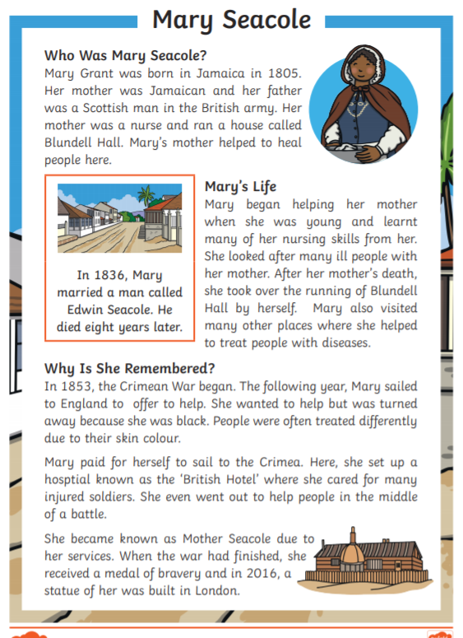
Reading Comprehension – Year 3
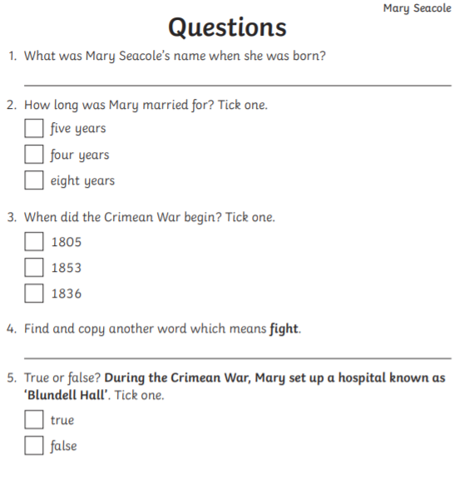
6. Where did Mary learn her nursing skills?
_____________________________________________________________________

7. Why was Mary turned away in London when she offered to help in The Crimean War?
_______________________________________________________________________

_______________________________________________________________________

8. Name two good things that happened when the war had finished.
_________________________________________________________________________

__________________________________________________________________________

