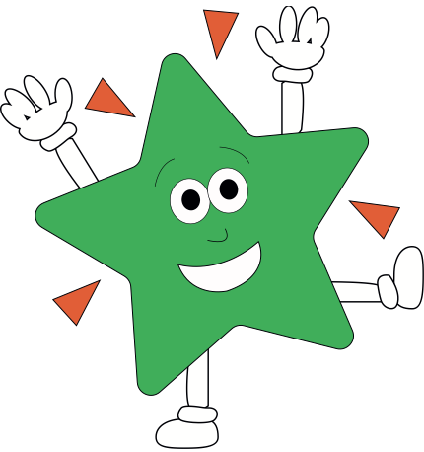rld

**Science**Our focus this half term will be on materials. We will be exploring properties of materials, thermal and electrical conductors and insulators, separating mixtures and irreversible changes.

**Maths**

Position and direction, including grid co-ordinates, translation, symmetry and reflection

Converting units, including Kilograms and kilometres, millimetres and millilitres, and time.

**English**: Narratives: Reading skills using mystery stories, then writing a mystery story including suspense and tension

Poetry: Mystery poems in different styles including shape poems and acrostics

SPELLING TESTS ON WEDNESDAYS

LIBRARY BOOKS IN ON MONDAYS

**PE/Games**

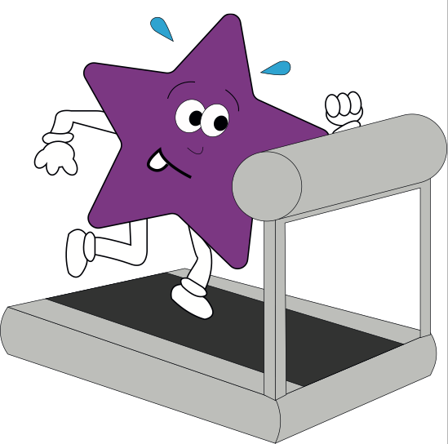

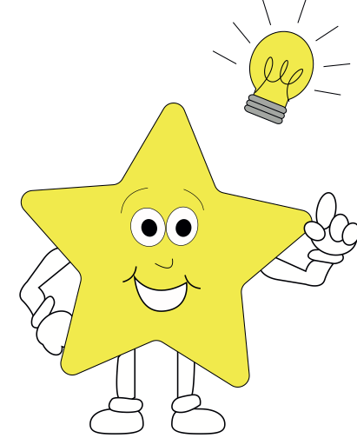

**RE**Our focus this half term will be solely on Humanism. This will include studying the humanistic view and beliefs, their symbols, the key thinker and how humanists would react in given situations.

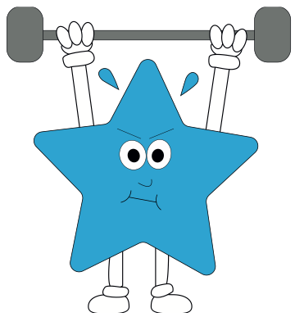

**Theme  
Art:**We will be studying local architecture and how to draw in perspective. We will then draw and paint a representation of local buildings  
  
**History:**We will be studying the architecture of the local area how Colchester is so full of historical interest.

**PE**EPC lessons will be focused on a mixture of athletics and striking games **French**

Oral and written work on:

Animals, sports and holidays.

**Pirates of the Curry Bean**Our school play will take up large amount of out afternoon lessons this term. It covers many objectives in areas such as drama, reading, speaking and listening and music.

