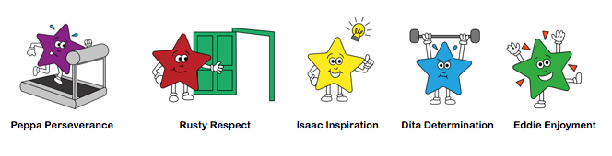

Home Learning for Class 2 Week 8th Feb Amazing People: KS1 Focus: Mary Anning Fossil Hunter

English  Phonics,– see separate plan | Non – Pupil Day | Class Zoom Tuesday 9:30am Show & Tell  Task: Write your recount for half term  Write about the most interesting thing you did  Can you write detailed sentences with…  When?  Time & Joining words  First, Then, Next  And, so, while, because  What did you do? Where?  Verbs/nouns  How did you do it?  Adverbs: bravely/quickly  Great describing words for thoughts & feelings:  How did you feel?  What did you think?  Can you write on the lines using finger spaces?  Can you use your phonics mat & rainbow words to help you with spelling? | Read ‘Stone Girl, Bone Girl’ about the life of Mary Anning  What did you find out about Mary Anning?  Write sentences about Mary Anning  Write a fact file about Mary Anning | Word endings – See separate plan | Spelling & Handwriting – see separate plan
Maths | Hit the Button Top Marks Games – can be used instead of TT Rock Stars to practise number bonds & number skills – can your child beat their score? https://www.topmarks.co.uk/maths-games/hit-the-button
 |  | TT Rockstars/Hit the Button (5mins)  https://vimeo.com/500466597  worksheet - Numbers to 50. | TT Rockstars/Hit the Button (5mins)  https://vimeo.com/500467345  worksheet - Counting forwards and backwards between 50 | TT Rockstars/hit the Button (5mins)  https://vimeo.com/500467998  worksheet - Tens and ones | TT Rockstars/Hit the Button (5mins)  https://vimeo.com/500468562  worksheet - Represents numbers to 50
 |  | worksheet - Reading and writing numbers to 50 | Place value game to 50  Click on the link above | worksheet - Tens and 1s | worksheet - Place value Dienes -  If you decide to print this game, then please try to print with more to a page. This will save on paper. Any trouble please just shout!
Other |  | History: How do we find out about the past?  History: Who was Mary Anning?  Why was she important?  https://www.youtube.com/watch?v=Of5sK8p2rZY  https://www.bbc.co.uk/teach/class-clips-video/geography-ks1-ks2-fossil-hunting-along-the-jurassic-coast/zbbrkmn  Fossils  Key words – match the words to the meanings  *Task – Be an excavator – Cookie sheet (task to try during the week) | PE:  https://www.youtube.com/watch?v=DqAOMrZkht0&list=PLoOc9M0VgduMnQiJ56Gw5TX7wsGIF7kmv&index=4 – Andy’s wild workouts  https://www.youtube.com/user/CosmicKidsYoga - Yoga for kids  https://www.nhs.uk/10-minute-shake-up/shake-ups  https://family.gonoodle.com/ | Computers: Purple Mash | RE: Lent  Watch video  Act of Kindness everyday

