Home Learning for Class 5
Week 8
1st – 5th March
 | Monday | Tuesday | Wednesday | Thursday | Friday
Maths | Translation  Complete the sheets entitled ‘Translation of Shapes’  Tune into dojo for Mr Easterbrook’s video input.  5 minutes minimum TT Rockstars time | Translation  Complete the sheets entitled ‘Translation in four quadrants’  Tune into dojo for Mr Easterbrook’s video input.  5 minutes minimum TT Rockstars time | Translation  Use the sheets entitled ‘Blank quadrants’ to draw your own shapes and translate them  Tune into dojo for Mr Easterbrook’s video input.  5 minutes minimum TT Rockstars time | Reflection  Complete the sheets entitled ‘Drawing reflected shapes’  Tune into dojo for Mr Easterbrook’s video input.  5 minutes minimum TT Rockstars time | Reflection  Use the sheets entitled ‘Blank quadrants’ to draw your own shapes and reflect them  Tune into dojo for Mr Easterbrook’s video input.  5 minutes minimum TT Rockstars time
English | Reading Comprehension  Complete the comprehension sheet entitled ‘Poetry Reading Revision Mat’  20 minutes reading time | Compound Sentences  Complete the sheet entitled ‘Compound Sentences’  Tune into dojo for Mr Easterbrook’s video input.  20 minutes reading time | Subordinate Clauses  Complete the sheets entitled ‘Subordinate Clauses’  Tune into dojo for Mr Easterbrook’s video input.  20 minutes reading time | World Book Day  It has now been almost exactly a year since we first closed the school due to COVID. If you were to write a book linked to events from the past year, what would it be called? What would the front cover look like? Be light-hearted with your approach.  Tune into dojo for Mr Easterbrook’s video input.  20 minutes reading time | Home learning Report  Write yourself a home learning report for the past 8 weeks. Come up with the headings for yourself. This is a bit of fun rather than a serious report on learning so you could report on ‘ability to get up early’, ‘progress in Fortnite’ as well as subjects such as ‘Maths’.  Tune into dojo for Mr Easterbrook’s video input.  20 minutes reading time
Other | Science  Year 6:  https://classroom.thenation  al.academy/lessons/how-is-oxygen-transported-around-our-bodies-60vk6r  Year 5: https://classroom.  thenational.academy/less  ons/who-is-katherine-john  son-61gpar | Computing  Create a PowerPoint presentation about a book/book series of your choice. The focus is on the quality of your presentation. Explore the use of transitions, text boxes, hyperlinks, animations, importing pictures, backgrounds and writing clearly in your own words. | World Book Day Preparation  Make an accessory to represent a book character for tomorrow’s celebration assembly. This could be a mask, headdress, clothing or iconic prop your character would own. | 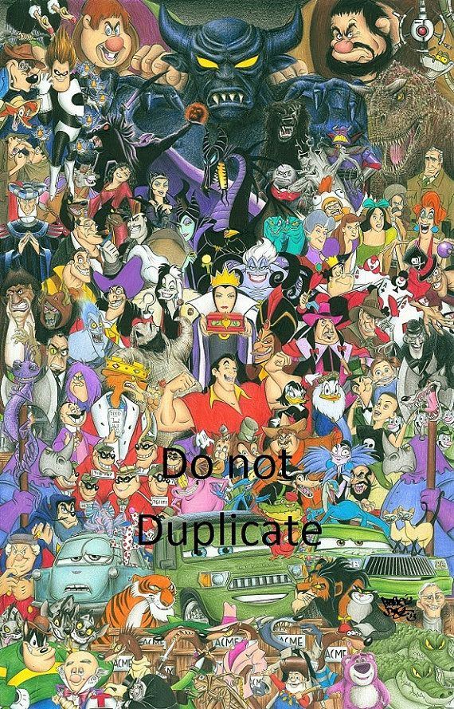  World Book Day  Create a montage of characters and settings from books  you have read. If you  don’t feel confident  drawing for the  whole of the task,  you can  use writing too. | PE  Create your own game that can be played at home. This game could be based upon an existing game or something completely new. It does need to encourage exercise or the development of a skill such as striking, throwing, running or jumping. Write the rules to your game and play it if you can.

