A World of Difference

**Mathematics**

Numbers to 10 – ordering, comparing, addition and writing numerals

Position and Space

2d shapes (circle and tri)

Position and Space

1 more/less

4 sided shapes

Night and day

**Personal Social & Emotional Development**

 **Weekly circle time sessions**

Staying safe

Being gentle

Rights and Responsibilities

Identifying talents

Friendships

**Communication and Language / and Literacy**

Bonfire Night – people who help to keep us safe from danger - firefighters/police/paramedics ‘Superheroes in Disguise’ book ‘Charlie the Firefighter’ book

Elmer’s/Kipper’s birthday

Diwali non-fiction text 14th Nov

Christmas Story/ Stickman

**Skills:** Daily Animaphonics to support reading and spelling.

Segmenting the letters in words to spell, writing labels, writing simple phrases, writing lists.

**PE/Games**

Art Attack



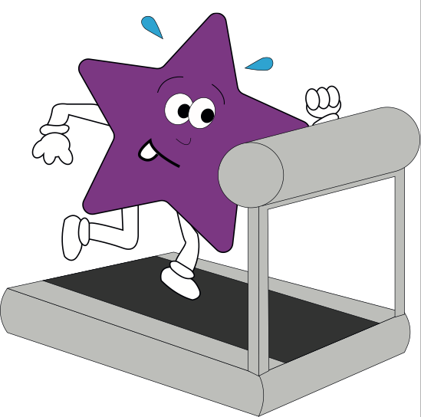

**Expressive Arts and Design**

Create a fire work picture using a computer paint programme.

Make a clay Diva lamp

Christmas decorations: tree decoration

Painting skills – developing brush grip

Plan a party for our Class Dinosaur!

Role play: emergency services; police, fire fighters, lifeboat rescue team.

Christmas Post Office. Party shop.

Small world: emergency services, stick man.

**Understanding the World**

**The world:** water play, mud kitchen, sensory play and large scale equipment outside. We will also enjoy snacks from around the world with Tuesday Travels.

**People and Communities:**

Discuss family celebrations and traditions, compare with others.

RE: create our own class prayer book.

**Technology** Paint programme – firework/Christmas picture.

Maths/Phonics activities on

IPAD/Laptop

**Physical Development**

* P.E with Mr Askew to explore spatial awareness and group games (Monday)
* Forest Schools – Mr Askew
* Moving on large vehicles outside during continuous provision.
* Developing skills to independently change clothes for PE and to put on coat.
* Dough Disco – to help pupils develop a good pencil grip and strengthen their fine-motor skills in a fun way.
* Baking biscuits/cakes – following instructions and keeping safe and healthy.

