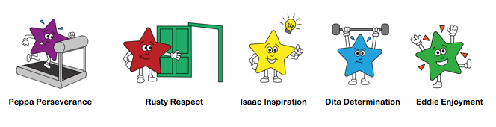

Please upload daily learning to Tapestry
Little Daily Tasks:
- What day is it today? What day was it yesterday? What day is it tomorrow? You could have the days of the week (Monday to Sunday) on display.
- Try to share a book, this could be a book that the adult reads, or a levelled scheme book. Discuss the pictures, who is in the story? (characters), where does the story take place? (setting) and what is happening? (Up to 10 mins) This could be your bedtime book too.
- In Class 1 we have a feelings chart. Every morning (and throughout if their feelings change) pupils place their photo onto one of coloured feeling jar pictures. We like to talk about our feelings, discussing why we may feel that way and how we can help one another.
- Please practise putting shoes on and doing up zips independently too.

DOJO Videos/Home links:

Monday | Whole school zoom assembly  Mrs L read Aliens Love Underpants video
Tuesday | Class catch up on zoom
Wednesday | Mrs L sentence lesson
Thur | Gold book assembly zoom ‘World book day’ wear your mask/headdress
Fri | Learning Collage

PHONICS: Up to 15 mins
 | Group 1 | Group 2
Monday | Recap the letter sound ‘oa’ with the action.  Read all letters as-quick-as-a-flash  Choose the game on phonics play – ‘picnic on pluto’ phase 3 set 7 (oa)  Use a brush & water/chalk to write some ‘oa’ words in your garden.’  Rainbow words – whack it! | Recap the letter sound and action for ‘er’  Read all letter sounds as-quick-as-a-flash  Play the game on Phonics Play – Picnic on Pluto, Phase 3 set 7 (er).  Use a brush & water/chalk to write some ‘er’ words in your garden.’  Rainbow words – whack it!
Tuesday | Read all letters as-quick-as-a-flash.  Teach or’  Look at phase 3, lesson ‘or’ on AnimaPhonics  Read the story and do the action.  Read the ‘ew’ words.  Follow buzzy bee and write ‘ew’.  Read the ‘reading sheet’.  Can you make some EW words on your phoneme frame/ or write them on your whiteboard?  Rainbow words as-quick-as-a-flash. | Read all letters as-quick-as-a-flash.  Teach ‘ew’  Look at phase 3, lesson ‘ew’ on AnimaPhonics  Read the story and do the action.  Read the ‘ew’’ words.  Follow buzzy bee and write ‘ew’.  Read the ‘reading sheet’.  Can you make some EW words on your phoneme frame/ or write them on your whiteboard?  Can you write a sentence containing an EW word?  Rainbow words as-quick-as-a-flash.
Wednesday | Recap the letter sound and action for ‘OR’  Read all letter sounds as-quick-as-a-flash  Adult to have OR words written down in garden (chalk, bits of paper) adult say a word and child has to find it or jump on it.  Make the following ‘OR’ words: (could write this outside)  Sort, port, short, born, worn (use the 3 box phoneme frame)  Rainbow words as-quick-as-a-flash. Spread them out, face down, pick one up and read the word. | Recap the letter sound and action for ‘EW’  Read all letter sounds as-quick-as-a-flash  Adult to have EW words written down in garden (chalk, bits of paper) adult say a word and child has to find it or jump on it.  Make the following ‘EW’ words: (could write this outside)  Grew, threw, blew, screw, drew(use the 3 or box phoneme frame)  Rainbow words as-quick-as-a-flash. Spread them out, face down, pick one up and read the word.
Thursday | Read all letters as-quick-as-a-flash.  Teach oo’ (short OO sound)  Look at phase 3, lesson ‘oo’ on AnimaPhonics  Read the story and do the action.  Read the ‘oo’ words.  Follow buzzy bee and write ‘oo’.  Read the ‘reading sheet’.  Can you make some OO words on your phoneme frame/ or write them on your whiteboard? book cook foot look wood  Rainbow words as-quick-as-a-flash. | Phase 3 completed!  Use Thursday and Friday to recap all letters and rainbow words.  Recap any letter lessons that your child is still unsure of.
Friday | Recap the letter sound and action for short ‘OO’  Read all letter sounds as-quick-as-a-flash  Play roll and read short oo game.  Write short ‘oo’ words outside using chalk, brush and water.  Rainbow words as-quick-as-a-flash. Spread them out, face down, pick one up and read the word. | Phase 3 completed!  Use Thursday and Friday to recap all letters and rainbow words.  Recap any letter lessons that your child is still unsure of.

Dough Disco/Handwriting 5-10 mins every day
Start with Dough Disco or a funky finger activity (tweezers and pom poms, etc).
Monday: r Tuesday: n Wednesday: m Thursday: p Friday: review all short mantis letters

Refer to my 5th February video about writing patterns and writing mediums –the pattern above will help with the mantis letters, plus drawing vertical lines from top to bottom.. Please don’t expect formation to be perfect at this stage as we spend all year practising a little every day.

Maths Focus: (up to 20mins) Shape
Activity 1 | https://www.youtube.com/watch?v=RRiWpCfp75g  Take the 2D shapes from your home learning box? Look at the corners and sides of each shape? Which has the most/least? These shapes are flat shapes.  Can you go on a shape hunt around the house/garden?
Activity 2 | https://www.youtube.com/watch?v=pfRuLS-Vnjs  Draw around each of your shapes, add eyes, arms, antennae to create your own little shape aliens.  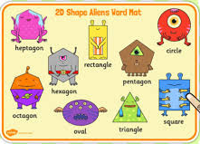
Activity 3 | https://www.twinkl.co.uk/go/resource/2d-shape-aliens-interactive- labelling-activity-tg-84-newlink  Design a pair of pants and decorate with 2D shapes. Draw around shapes, stick craft shapes, etc.
Activity 4 | https://www.youtube.com/watch?v=guNdJ5MtX1A (This is Mrs Lawrence’s favourite!!!!)  Listen to the song above.  Listen to the song again and pause after every shape, can you find that shape in your home? Remember these are 3D shapes so they are solid.
Literacy/Theme: SPACE Aliens Love Underpants

Pick one/two activities every day from below (at least 10 mins for each activity)

Cutting skills/Fine motor activity
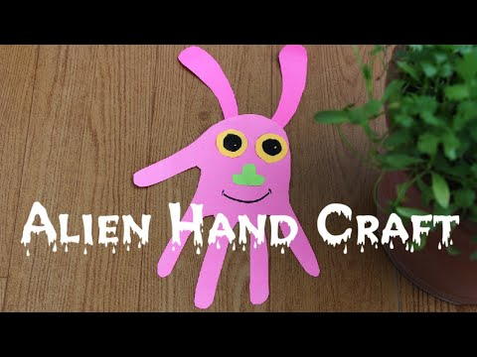 This can be as simple or elaborate as you wish. Draw around your hand, cut it out and then colour or add craft pieces to create your very own Alien.
How many eyes? How many antennae? How many arms and legs? What colour will it be? Will you hang it up or add a lolly stick? Will you give your alien a funny name?

Technology Activity:
Explore space on Purple Mash
Can you draw an alien? Can you draw a pair of space pants?

Physical Activity (Do these on different days)
- https://cosmickids.com/video/bop-the-alien-a-cosmic-kids-yoga-adventure-app-preview/
- https://www.youtube.com/watch?v=AFIqSaZM2D0
- Help hang out the washing – count how many item there are? How many pegs will you need? Hopefully there are no aliens lurking in your washing basket!!

Communication and Language/PSHE

- Are aliens real? Discuss

- Aliens like to steal underpants? Is that ok? Should they be stealing things? Is stealing right or wrong?
Literacy (Reading)
- Read the story, talk about what happens in the story, what is your favourite part? Mrs L read story on DOJO Monday
- Sequence the pictures from the story
- Can you read some alien words on the powerpoint?
Literacy (Writing)
- Write an alien sentence Mrs L video
Expressive Arts and Design activity:

1.Sing the Alien rhymes. Can you add actions too? Can you clap along to the rhyme?

2.Before Thursday’s Gold Book assembly, make a mask or headdress based on your favourite book.

Travelling Tuesday:  Please travel to a country of your choice, or if you haven’t done so already, you could visit the USA and explore the Kennedy Space Centre online. |  | Understanding the world  Read the letter from the aliens.  Can you help them solve the problem of sorting magnetic and non-magnetic objects?

