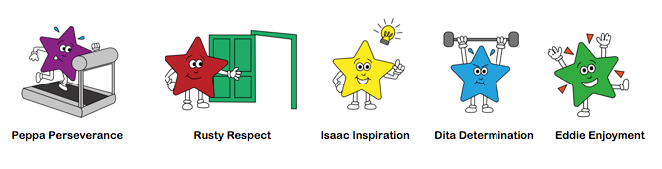

Home Learning
Useful websites: Nearly all are offering free access for homelearning

Reading –OXFORD OWL Ebookshttps://www.oxfordowl.co.uk/for-home/find-a-book/library-page/ Please try to share a book daily – this could be a levelled book or a book for pleasure.
https://libraries.essex.gov.uk/e-books-e-audio-e-magazines-and-book-groups/e-books-and-e-audio/
Phonics:
https://www.animaphonics.com/
https://www.phonicsplay.co.uk/

Physical Development
https://cosmickids.com/
https://www.bbc.co.uk/programmes/p06tmmvz (Andy’s wild workouts)
https://www.channel5.com/show/milkshake-bop-box-boogie/

General:
Purplemash –Activities for all subjects available on Purplemash – over the coming weeks there will be activities linked to Purplemash. You will already have your child’s log in, but if there’s any problems I can resend this information.
https://www.twinkl.co.uk/resources/covid19-school-closures
https://abcdoes.com/home-learning/

Please upload daily learning to Tapestry
Little Daily Tasks:
- What day is it today? What day was it yesterday? What day is it tomorrow? You could have the days of the week (Monday to Sunday) on display.
- Try to share a book, this could be a book that the adult reads, or a levelled scheme book. Discuss the pictures, who is in the story? (characters), where does the story take place? (setting) and what is happening? (Up to 10 mins) This could be your bedtime book too.
- In Class 1 we have a feelings chart. Every morning (and throughout if their feelings change) pupils place their photo onto one of coloured feeling jar pictures. We like to talk about our feelings, discussing why we may feel that way and how we can help one another.
- Please practise putting shoes on and doing up zips independently too.

PHONICS: Up to 15 mins
 | Group 1 | Group 2
Monday | Quick-as-a-flash read all letters learnt so far.  Teach ‘Z’  Look at phase 3, lesson ‘Z’ on Animaphonics.  Read the sound and do the action, adult to read the story.  On the next page, read the words and blend them together.  Follow the buzzy bee and write the letter, first with your finger and then on (paper, book, chalkboard, whiteboard, in flour or sand tray)  Look at the reading page. Talk about the picture and read the caption.  Using letters magnets and frame in home box, make a couple of words from the caption sheet, adult to say word, child segment word and child makes it.  Rainbow words as-quick-as-a-flash. (Mrs L Video) | Read all letters learnt so far as-quick-as-a-flash  Look at phase 3, lesson ‘oo’ (long 00 sound) on animaphonics.  Read the sound and do the action, adult to read the story.  On the next page, read the words and blend them together.  Follow the buzzy bee and write the letter, first with your finger and then on (paper, book, chalkboard, whiteboard, in flour or sand tray)  Look at the reading page. Talk about the picture and read the caption.  Using letters (cards/magnets), make a couple of words from the caption sheet, adult to say word, child segment word and child makes it. Can you read the caption, hide the caption and write the caption?  Rainbow words as-quick-as-a-flash.
Tuesday | Read all letters, quick-as-a-flash.  Recap the letter sound and action for ‘z’’  Play a game on PHONICS PLAY (Phase 3, set 7)  Lay some letter cards/magnets on the floor, adult says a word, child has to pick the letters up that they need to make the word, and make it on their phoneme frame.  Words: Zip, zap, yes, mix, yuck  Rainbow words as-quick-as-a-flash. | Read all letters, quick-as-a-flash –  Recap the letter sound and action for ‘oo’  Play the treasure and bin game. Read the word, if it’s fake (alien word) then put it in the bin and if it’s real, put it in the treasure chest.  Outside (if possible) adult say a word and child writes it with brush and water. Inside: whiteboard and pen, flour tray, sand tray, pencil and paper.  Real words: mood, loom, food, soon  Fake alien words: voot, shoob  Rainbow words as-quick-as-a-flash.
Wednesday | Recap all letters as-quick-as-a-flash  Follow Animphonics lesson for ‘qu’  Once completed use letters/magnets or write/make the following words; quick = qu-i-ck, quit = qu-it,  Quack = qu-a-ck quiz = qu-i-z Mrs L video  Read Rainbow words. | Read all letters learnt so far as-quick-as-a-flash  Look at phase 3, lesson ‘ai’ on animaphonics.  Follow the lesson activities just like on Monday.  Using letters (cards/magnets), make a couple of words from the caption sheet, adult to say word, child segment word and child makes it. Can you read the caption, hide the caption and write the caption? ‘rain on a sail’.  Rainbow words as-quick-as-a-flash.
Thursday | Read all letters, quick-as-a-flash –  Recap the letter sound and action for ‘qu’  Outside/inside  Play hopscotch by reading a word and jumping on it.  Quiz, quick, quit, quack, zip, buzz, fizz - see my photo post on DOJO for 22-01-21  Complete the ‘qu’ worksheet.  Rainbow words as-quick-as-a-flash. | Read all letters, quick-as-a-flash –  Recap the letter sound and action for ‘ai’  Outside/inside  Play hopscotch by reading a word and jumping on it.  Rain, chain, train, sail, maid - see my photo post on DOJO for 22-01-21  Complete the ‘ai’ worksheet.  Rainbow words as-quick-as-a-flash.
Friday | Recap all letters as-quick-as-a-flash  Follow Animphonics lesson for ch’’  Read the sound and do the action, adult to read the story.  On the next page, read the words and blend them together.  Follow the buzzy bee and write the letter, first with your finger and then on (paper, book, chalkboard, whiteboard, in flour or sand tray)  Look at the reading page. Talk about the picture and read the caption.  Using letters magnets and frame in home box/ or whiteboard and pen, make a couple of words from the caption sheet, adult to say word, child segment word and child makes it.  Words: chat, chip, chips, chin, chill, chop)  Read Rainbow words. | Read all letters learnt so far as-quick-as-a-flash  Look at phase 3, lesson ‘igh’ on Animaphonics.  Follow the lesson activities just like on Monday.  Using letters (cards/magnets), make a couple of words from the caption sheet, adult to say word, child segment word and child makes it. Can you read the caption, hide the caption and write the caption? ‘rain on a sail’.  Rainbow words as-quick-as-a-flash.

Dough Disco/Handwriting 5-10 mins every day
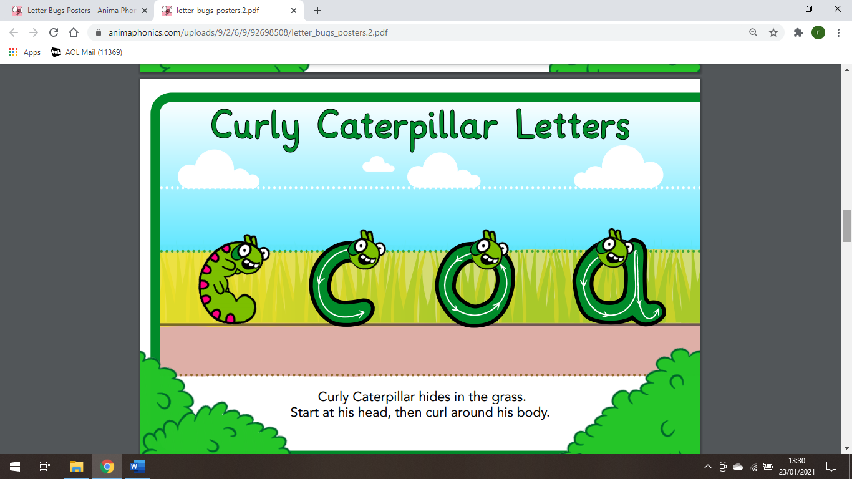 PART 1 c o a
(Large versions found under, display and letter bug letters on Animaphonics)
Always start with some music and a ball of dough. Follow the actions; squeeze dough, ball dough, pat dough, pinch dough and roll dough into a sausage. (a few minutes)
Or do a funky finger activity with tweezers and pom poms.
Monday: c Tuesday: o Wednesday: a Thursday and Friday: review and practise all three.
Say the letter, follow the formation of the letter with your finger and lastly write the letter – you can vary how you write it every day by using; pen, pencil, paint brush, chalk, crayon or in a sand/flour tray.

Maths Focus: Number (up to 20mins) Pairs and number bonds (numbers and objects)
Activity 1 | https://www.youtube.com/watch?v=6RfIKqkvHTY counting to 10 song  Next lay out your number cards 0-10 on the floor – if you need to you can use your number line as a reminder.  Next, look at you Numicon shapes, which Numicon shape matches the number card?  Count the Numicon holes/white circles and then lay the shape next to each number card.  Use 1 more/less to help you when laying down the Numicon shapes. Mrs Lawrence video
Activity 2 | Which two Numicon shapes make 5? Can you make 5 using more than 2 Numicon shapes? (1+1+3) (2+2+1) If you’re happy with 5, then try 10.  You could write the numbers on your whiteboard like this (2+3, 4+1, 5+0) (10+0 , 9+1, 8+2, etc) Don’t forget to take a photo once you’ve finished.  A challenge to try with 5 or 10 objects:  Hidden Bonds: Adult to show two cups. Explain that you have 5 counters hidden inside the cups. Ask the children how many counters could be in each cup? Could this cup have 0 counters? Could this bucket have 4 counters? How do you know?  Finish with this song: https://www.youtube.com/watch?v=jOU3axPomRg 5 song  Or https://www.youtube.com/watch?v=n2Nfez2e67k 10 song
Activity 3 | Read the story ‘Simon’s Sock – Mrs Lawrence video  After the story discuss pairs, explain how a pair is two things that are used together.  Look for pairs of things around the house; socks, gloves, shoes, hands, feet, salt & pepper, etc)  Using number cards: 0, 1,2,3,4 and 5, turn them over and play a pairs game. Can you turn over the cards and match them the ones that make a total of 5? These are number pairs. You could try this for ten.
Activity 4 | Read the story Noah’s Ark, discuss the animals entering in twos, in pairs.  Can you gather any toy animals you have at home and put them into pairs?  Encourage children to investigate making pairs using different quantities of animals, cubes or counters. Which objects will make pairs and which will have one left out? Do they notice a pattern? The one left out is odd.
Literacy/Theme: This week our book focus will be ‘Arctic Animals’. Watch Mrs McMillan read the story on Tuesday.
Pick one/two activities every day from below (at least 10 mins for each activity)

Cutting skills/Fine motor activity  https://www.twinkl.co.uk/resource/t-g-258-arctic-animal-themed-cutting-skills-activity  Practise cutting different lines to reach the Arctic animals. | Communication and language  Ask your adult to read the clues to discover which Arctic animal it is.  https://www.twinkl.co.uk/resource/t-t-8434-arctic-animals-what-am-i-interactive-powerpoint-game
Technology Activity:  Log into Purple mash and find out about Arctic animals and where they live? | Physical Activity (Do these on different days)  - Andy’s Wild Workouts (Cbeebies) – Arctic https://www.bbc.co.uk/iplayer/episode/p06tmrxh/andys-wild-workouts-series-1-10-arctic  - For fun: Yoga with Rebecca and Duggee – Cbeebies  https://www.youtube.com/watch?v=jVS8xNGaWF8  - Musical animals: play some music, move like an Arctic animal and when the music stops freeze like the animal too. Try this for different Arctic animals – arctic fox, polar bear, Arctic hare, husky or Narwhal.
Literacy Activity

Make your very own Arctic Animals poster. First draw the sea and snowy land. Then cut out the Arctic animals, stick them down and write their name labels.
Literacy activity  Write a simple sentence about a puffin  A puffin can fly and swim. Watch Mrs Lawrence  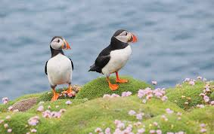  EXTRA activity: You could write about your favourite Arctic animal | Watch the video about the Inuit community that live in Canada.  https://www.youtube.com/watch?v=6UIrgAFW3aQ  https://www.twinkl.co.uk/resource/t-t-17102-inuit-information-powerpoint  please don’t read this word-for-word, just look at some of the pictures and discuss.  Can you make your own igloo using icecubes?  https://childsplayabc.wordpress.com/2019/02/05/ice-cube-igloo/  or if you have them, sugar cubes?
Expressive Arts and Design activity: (I must admit, I’m really intrigued by Narwhals Class 1)
https://kids.nationalgeographic.com/animals/mammals/narwhal/ look at the photos and watch the short video about Narwhals. They are real animals, but some call them the unicorns of the sea.
Could you decorate/make your very own Narwhal so that it looks magical.

https://www.projectswithkids.com/winter-scrape-painting-narwhal/

or
https://www.redtedart.com/toilet-paper-roll-narwhal-craft/ 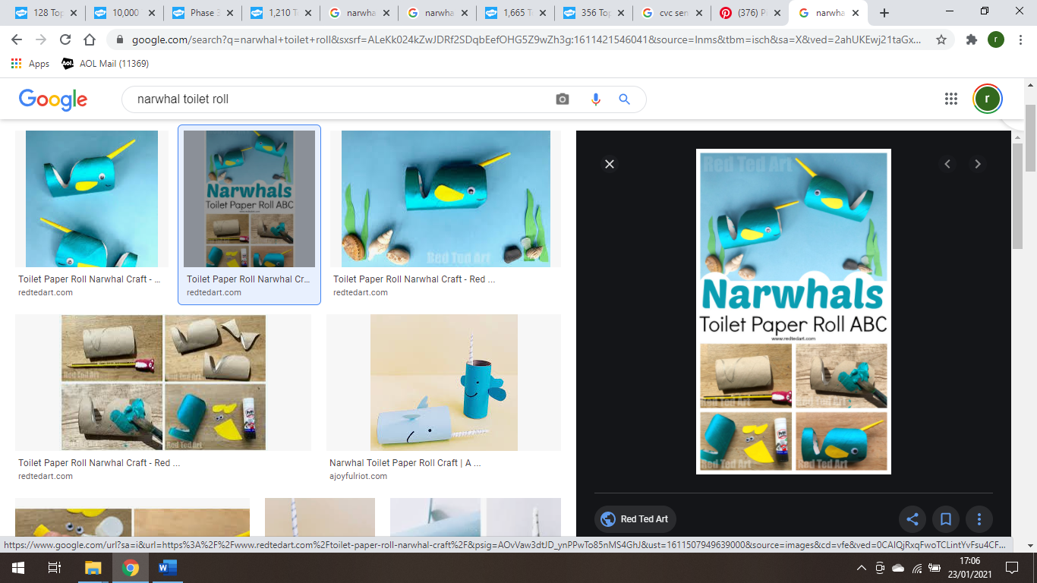

or maybe you would like to use your own creative ideas to make a Narwhal art work.

Travelling Tuesday: Find the Arctic on the map.  What are some of the names of countries near the Arctic?  Greenland, North Asia, , Sweden, Finland, Russia, the United States (Alaska), Canada, Denmark and Iceland are some of the countries.  Canada – pancakes and maple syrup?  (Groceries permitting) | Understanding the world  HOW DO ARCTIC ANIMALS STAY WARM?  Try out the experiment saved in the planning folder.
Turn-taking/managing behaviour
Play a board game – a good focus for turn taking and playing for enjoyment.

Listen to the story ‘Hands Are Not for Hitting’ discuss positive ways that we use our hands.
https://www.youtube.com/watch?v=aZGdwTqMGWo&t=116s

