Home Learning for Class 5 Week 1: 6th – 8th January
In school = Mr Easterbrook, Mrs Sibley and Miss Enoch
Working from home = Mr Tuttlebee, Mrs Martin and Miss Jowitt
 | Monday | Tuesday | Wednesday | Thursday | Friday
Maths | N/A | N/A | Short Multiplication  Start by multiplying a 4 digit number by a 1 digit number e.g. 2414 x 4. Then move onto:  - 5 by 1 e.g. 84721 x 7  - 6 by 1 e.g. 302988 x 9  Do you remember long multiplication? E.g. 348 x 23  You can then move onto the challenges in the video  Tune into dojo for Mr Easterbrook’s video input.  5 minutes minimum TT Rockstars time | 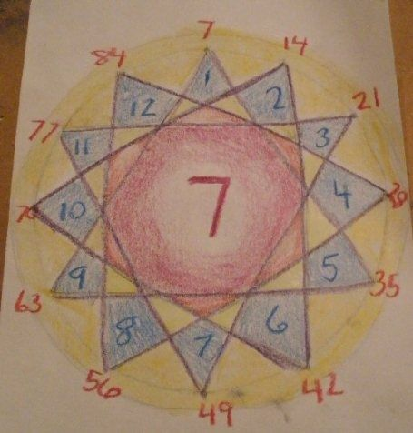  Times Table Focus  From your TT Rockstars practice, choose a times table you really want to nail!  Spend today’s and tomorrow’s lesson making fun revision guides to aid your learning.  Now is the time to crack that times table you have always found tricky  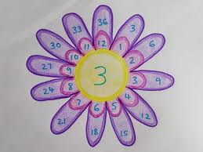  Tune into dojo for Mr Easterbrook’s video input.  5 minutes minimum TT Rockstars time | Times Table Focus  Continue your practice from yesterday.  Want to prove your success? Send me a video of you recalling your newly nailed times table e.g.  “One times nine is nine, two times nine is eighteen, three times nine is twenty-seven…  Tune into dojo for Mr Easterbrook’s video input.  5 minutes minimum TT Rockstars time
English | N/A | N/A | Biographies  Read the JK Rowling biography supplied in the email. Choose which level you wish to read depending on your confidence. Answer the comprehension questions which follow the reading. | Biographies  Use the JK Rowling biography from yesterday to read in depth. You may want to choose a different level of text. Highlight words, phrases or whole sentences which grab your attention. Annotate the text for grammar that you recognise e.g. what tense it is in, punctuation marks, facts, opinions. Write a list of what you think makes a successful biography. | Biographies  Write a short autobiography. This should detail some key events from your life. It should be in time order but can start from any stage of your life.  Aim to write 3-5 paragraphs, each one from a different time of your life. Think about the list you made yesterday.
Other | N/A | N/A | History  We are beginning our new topic of ‘Ancient Egypt’.  Write down everything you know or think you know about Egypt. Start with the most basic things you know and work your way up to facts you believe to be true. Once you have done this, write a list of at least ten questions you would like to have answered by the end of this topic. For example, how were the pyramids built? When was the last Pharaoh? Keep this work safe as it will show your progress in the topic when we finish it. | Geography  Research the Human and physical geography of Egypt:  What continent is it on? What is its climate through the year? How big is it? Capital city? Coastline? Rivers? Lakes? Mountains? Animals? Plants? Population size? Religion? Farming? Rich? Poor? Tourism?  Present your information as a PowerPoint, leaflet, poster, booklet or any other way you please. | History  Use the example timeline from the email as a base to create your own. You may use events from the example but research key events in ancient Egypt to make yours different. Make sure it is in chronological order and add pictures to represent each event.  Want an extra challenge? Include important events that happened in other parts of the world.

