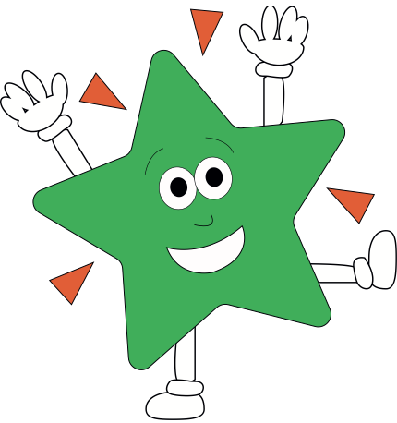A World of Difference

**Maths**

**Yr 1**

Number bonds to 10.

Addition of two numbers to bridge 10

Addition number sentences

Ordering numbers to 20

subtraction

**Yr 2**

Number bonds to 10

Addition of 2 digit and signal digit to bridge 20.

Subtraction.

Number formation for all children

Geometry

recognise, identify, classify and sort 2D & 3D shapes according to their properties

Shape patterns

**Science –**

**Yr 1 -** (Mrs Jinks)

**Yr 2 -** (Mrs Masterman)

**English**

Daily phonics sessions Grammar and Spelling activities related to year 1 and 2 objectives Handwriting practice Reading activities, including Guided Reading Narrative – stories/film related to theme of Australia

Christmas themed writing and stories

**PE/Games**

Art Attack

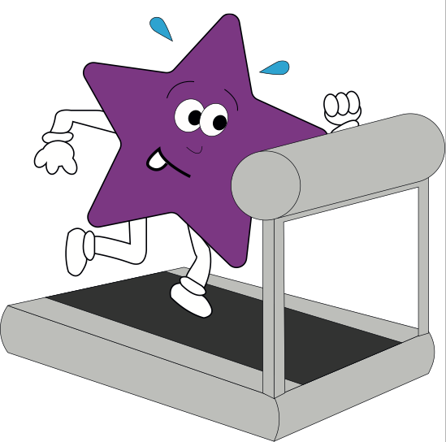

**Theme**

**Geography –** Learning about the Great Barrier Reef. Locating Australia and UK on maps, oceans and continents.

**Art/DT**

To make a Diorama about Australia

To design and make an Australian Christmas Card.

Christmas cooking

**Music**

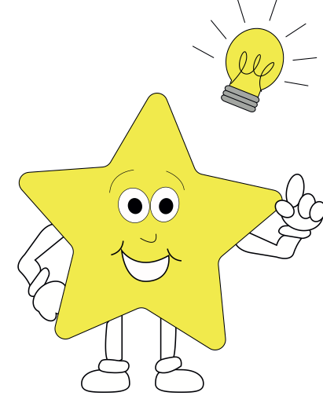

**Computing** Online safety Exploring Purple MashGrouping and Sorting

**French** – Mrs Locke, including conversations, songs and games related to colours,

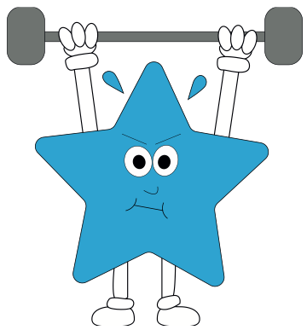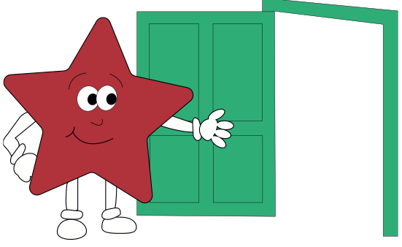

**RE& PSHE**

**PSHE**

Be yourself, its k to be different. How to talk about feelings

**RE**

Judaism- special words and stories

Christianity- Why does Christmas matter to Christians?