Home Learning for Class 3 w.c. 8th February

 | Mon | Tues | Weds | Thurs | Fri
Maths | Measurement - Length  Year 2  Measure length  https://www.bbc.co.uk/bitesize/articles/zcbwr2p  Year 3  Measure length  https://vimeo.com/503131096  Watch the videos and complete as much of the worksheet as you can.  TT Rock Stars 5mins | Year 2  Measure length cm  (worksheet only)  Year 3  Equivalent lengths (m & cm)  https://vimeo.com/504467081  TT Rock Stars 5mins | Year 2  Measure length m  (worksheet only)  Year 3  Equivalent lengths (mm & cm)  https://vimeo.com/504918866  TT Rock Stars 5mins | Year 2  Comparing length and height  https://www.bbc.co.uk/bitesize/articles/z9dp7yc  Year 3  Compare lengths  https://vimeo.com/506146737  TT Rock Stars 5mins | Year 2  Compare lengths  (worksheet only)  Year 3  Add lengths  https://vimeo.com/506146810  TT Rock Stars 5mins
English | Samuel Pepys  Reading comprehension  Continuing with our theme on diaries we are going to look at two famous diary writers from history.  Reading Time 15-20mins | Anne Frank  https://www.bbc.co.uk/bitesize/topics/z7d7gwx/articles/zm4v7nb  https://www.natgeokids.com/uk/discover/history/general-history/anne-frank-facts/  What can you find out about Anne Frank’s Diary?  Reading Time 15-20mins | Anne Frank’s Suitcase  (worksheet)  Reading Time 15-20mins | Commas in lists  (worksheet)  Reading Time 15-20mins | Spelling activity - Crack the Code  Please note this is to be done with these new spellings  Yr 2 Yr 3  hiking forgetting  hiked forgotten  hiker beginning  nicer beginner  nicest preferred  shiny preferring  being occurred  shining occurring  scary forbidden  scaring committed  Reading Time 15-20mins
Other | Geography  Capital cities  London is the capital city of England.  Can you remember the capital cities of the countries that make up the United Kingdom?  How many of the European capitals can you find?  (see worksheet) | Science  Year 2  What is a living thing?  https://classroom.thenational.academy/lessons/what-is-a-living-thing-70t3ae  Year 3  What is recycling and why is it important? https://classroom.thenational.academy/lessons/what-is-recycling-and-why-is-it-important-75h3gt | PE – Some suggestions to keep you active.  https://www.nhs.uk/10-minute-shake-up/shake-ups  https://www.bbc.co.uk/teach/supermovers  https://www.getset.co.uk/tokyo-ten | PSHE  Celebrating differences and similarities  https://classroom.thenational.academy/lessons/one-big-family-cthp2c | Computing/Music  Making Music: 2 Sequence  Have some fun with sounds! You need to drag and drop the different instruments in to the boxes.  The green triangle will play your tune to you. Drag the purple dot up and down the scale to make it go faster or slower.  Tips:  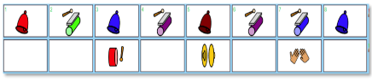  You can have different instruments in different rows, they will play at the same time.  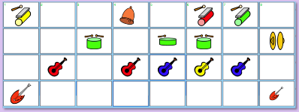  You don’t have to have an instrument in every box. Rest beats in music are good too.  Mainly today is about having fun with music. If you get a tune you like, save it and hand it to me so I can have a listen!

