A World of Difference

**Science**

**Yr 2 –** *Materials* : Identifying ,comparing and investigating the suitability of everyday materials *Living Things:* Identifying habitats and how living things are suited to their habitat *Plants:* Observing plants and bulbs **Yr 3 –** *Plants:* Different parts, transport and growth *Animals including humans:* Nutrition, skeleton and muscles *Living things and habitats:* Nutrition, skeleton and muscles *Rocks:* Fossils

**English**

Narrative – stories by Michael Foreman I’ll take you to Mrs Cole! Dinosaurs and all that Rubbish

Non-fiction - Tourist information brochure

Grammar and Spelling activities related to year 2 and 3 objectives Handwriting practice Daily reading activities, including Guided Reading

**Maths**

*Number: Place Value* Read and write numbers in numerals and words. Recognise place value of digits. Compare and order numbers Solve number problems

*Number: Addition and Subtraction*

Number bonds and related subtraction facts

Add and subtract numbers mentally and using formal, written methods

Solve addition and subtraction problems

‘Big’ Maths

Times Tables Rock Stars

**PE/Games**

Art Attack

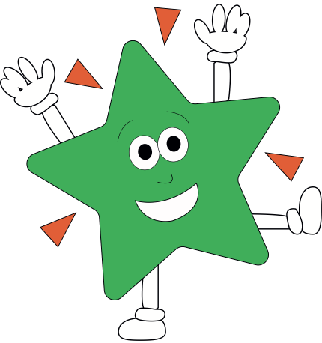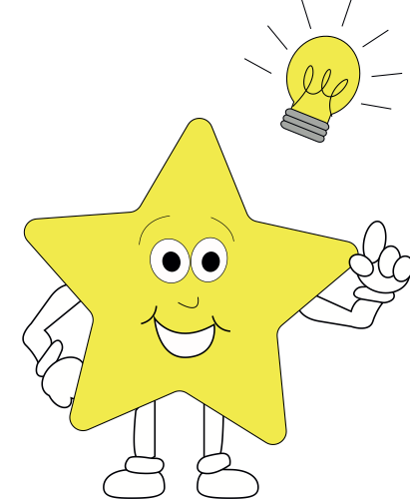

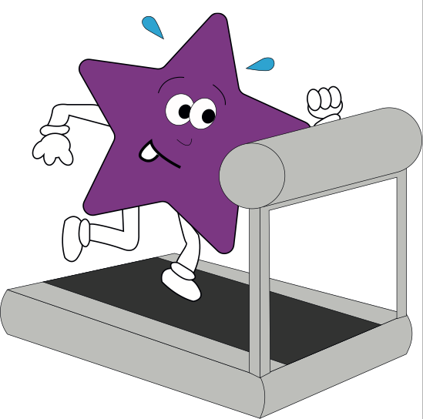

**Theme**

**Geography –**  Naming the countries of the UK, their capital cities and surrounding oceans Naming and locating some counties and major cities of the UKIdentifying types of settlements Using aerial pictures and ordnance survey maps

**Art/DT/** Foods from different cultures Pointillism - Study work by artists Paul Signac and Georges-Pierre Seurat. Create own pieces Charcoal drawings – London Landmarks

**RE**- **Creation/Fall**What do Christians learn from the Creation story? Using ‘Understanding Christianity’ to explore the Creation story in the Bible and what Christians believe about God and Creation  **PSHE** New beginnings, settling in Christian value - Responsibility Keeping safe

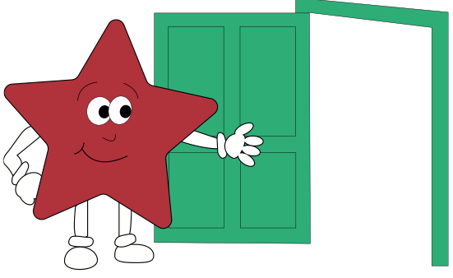

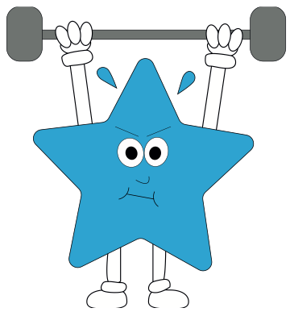

**Computing**  - Online safety Sharing and searching information Responding to email and communicating appropriately on computers understanding digital footprint Secure passwords and using a blog Recognising real and ‘spoof’ websites Age ratings and appropriate content **French**

Simple questions and answers, spoken phrases and simple conversations. Singing and new topic words.

**Music**

Learning to play the Clarinet (Yr 3) Using voices expressively and creatively by singing songs