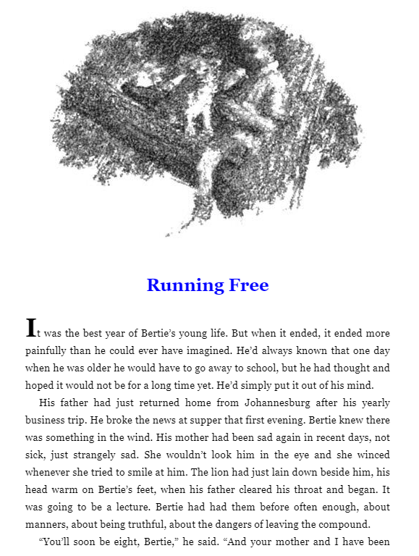

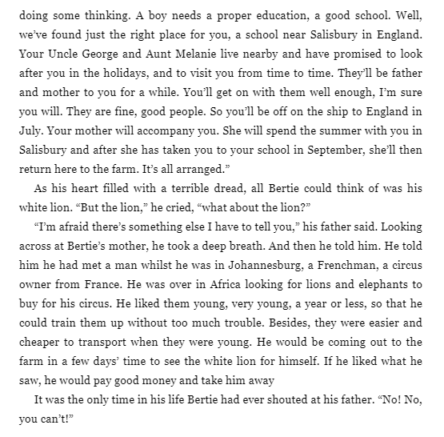

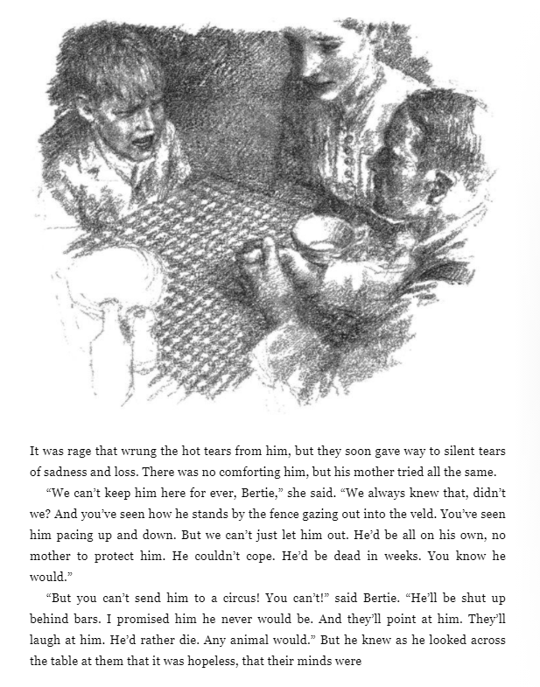

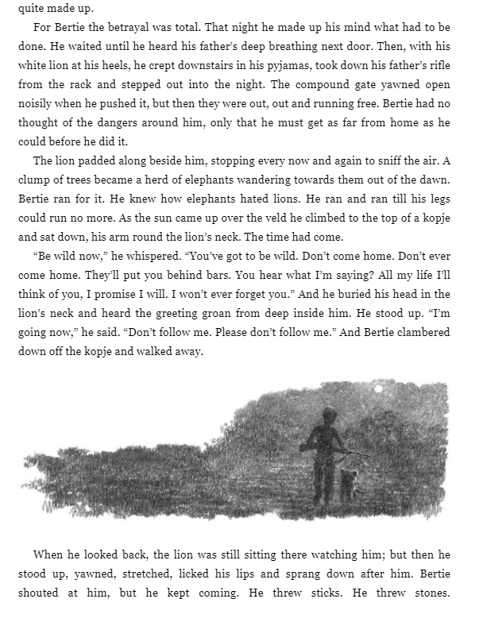

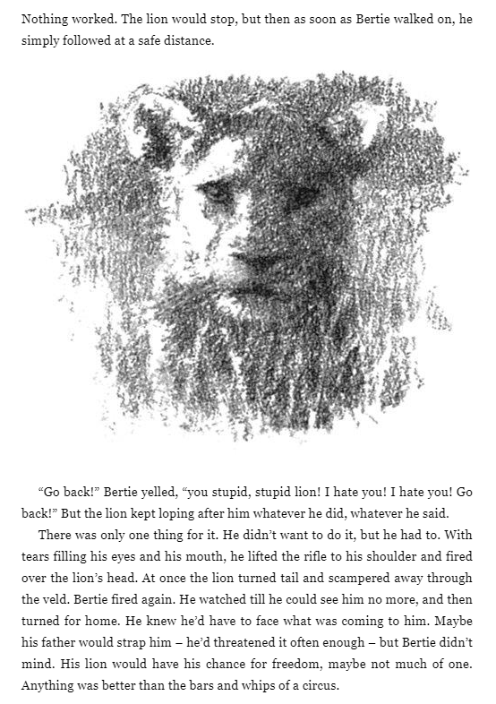

Work
- There were clues for Bertie that something was happening. Can you find these clues from the text?
- Bertie’s dad wants the Lion to go to the circus but Bertie wants to set him free. Can you give reasons for both and see both points of view? After, creating your list, explain which reason you think is best and why?
- In this chapter Bertie finds out that he is going to be sent away to England to a boarding school. You need to put yourself in his shoes and imagine that you have just been told that you will be sent away to South Africa to boarding school. Think about how you will feel, what you are looking forward to, what you might miss, etc… Think very carefully about and write it in first person as a diary entry.

