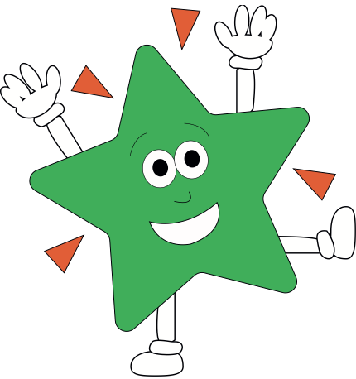A World of Difference

**Personal Social & Emotional Development and RE**

**Feelings** – naming and exploring feelings through circle time and learning activities based on the colour monster story.

Describing ourselves positively and talk about our needs and interests – Show and Tell, Book Talk will be introduced too.

Lots of games/learning activities that help us practise turn-taking, plus our ‘snack table’ will encourage our independent skills.

**Mathematics**

* Daily Maths songs.
* Reciting numbers in order up to 10, counting 1-1, counting items taken from a larger set, matching a number of items to a numeral, matching written and spoken numerals and being able to count accurately using one-to-one correspondence.
* 2D shapes (naming and describing) and introduce, 2-D shape patterns/pictures
* Positional language – where objects are?
* Practically comparing objects by capacity, length, size and weight
* 1 more and 1 less
* Sorting objects, shapes, by size, shape or chosen criteria.

**Communication and Language / and Literacy**

*Texts / stories include:*

*Colour Monster, Zog, Paw Patrol/Mighty Pups, nursery rhymes.*

**Skills:** lots of early phonics, listening to sounds through instruments, games and around the environment.

Show and tell/book talk and talk partners will build on early questioning and speaking and listening.

Drama skills, role play based on stories.

Singing nursery rhymes daily to build on S&L, and vocabulary.

**PE/Games**

Art Attack

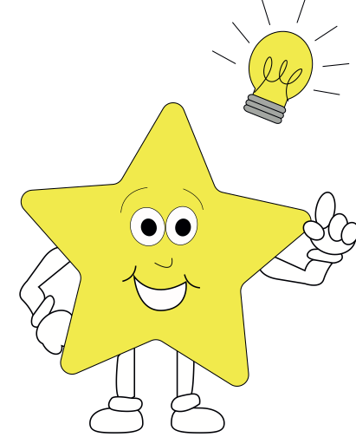

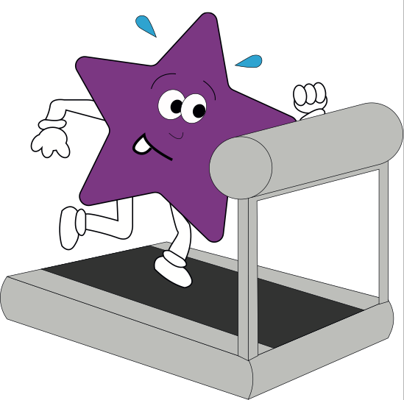

**Understanding the World**

**The world:** water play, mud kitchen, sensory play, and large scale equipment outside. We will also enjoy snacks from around the world with Tuesday Travels. **People and Communities:** Occupations, how we celebrate - shared through show and tell, photos and discussions. **Technology**

Computers and iPad to explore maths and literacy activities. Taking photos with the ipad. Using interactive whiteboard for our mark making and listening to stories on cd player.

**Expressive Arts and Design**

Self portraits using paint

Clay models of the paw patrol pups

Colour monsters using simple join techniques (straws, tapes).

Making our own Mighty Pups/Superhero mask and wristband

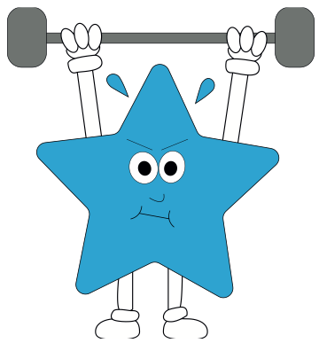

**Physical Development**

* P.E with Mr Askew/Miss S to explore spatial awareness, travelling in different ways – superheroes/dragons flying
* Parachute games
* Opportunities outside to balance and move in different ways. Moving on large vehicles outside.
* Developing skills to independently change clothes for PE and to put on coat.
* Dough Disco – to help pupils develop a good pencil grip and strengthen their fine-motor skills in a fun way.
* Ways to keep healthy – daily whole class snack time.

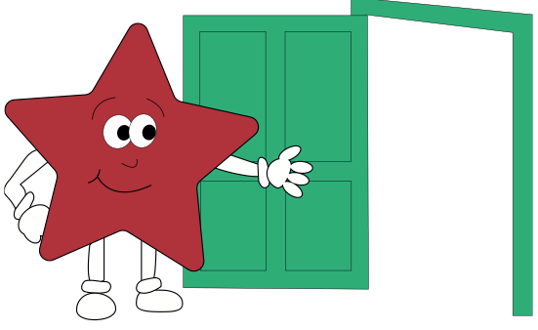

**French**

One session per week to explore greetings, numbers and colours.