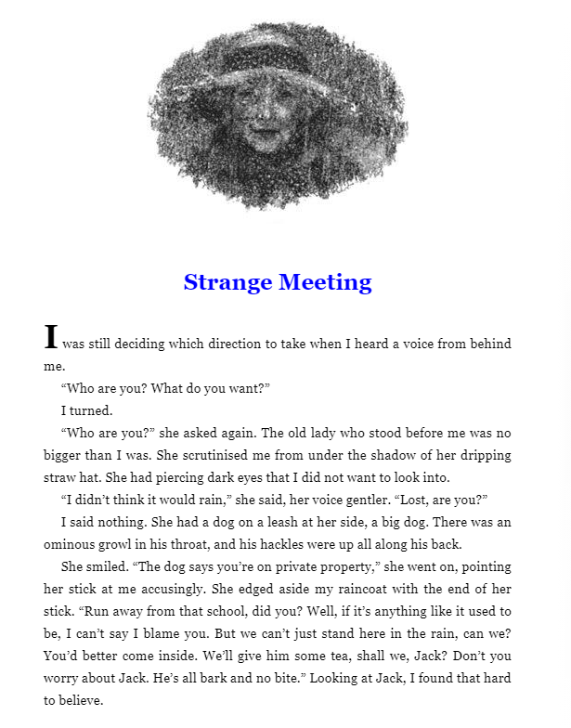

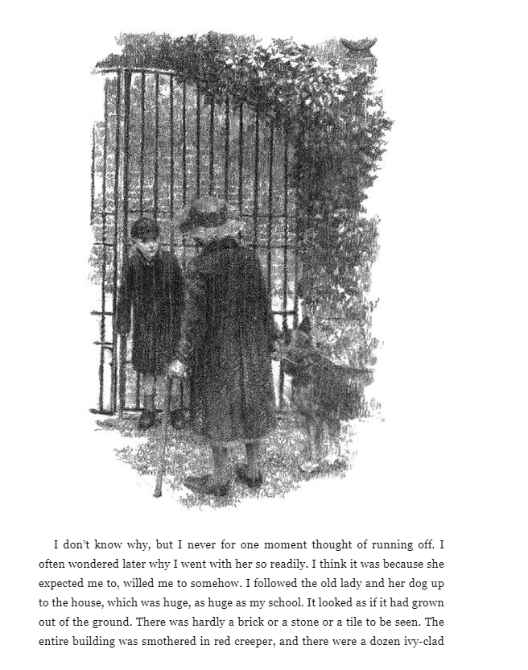

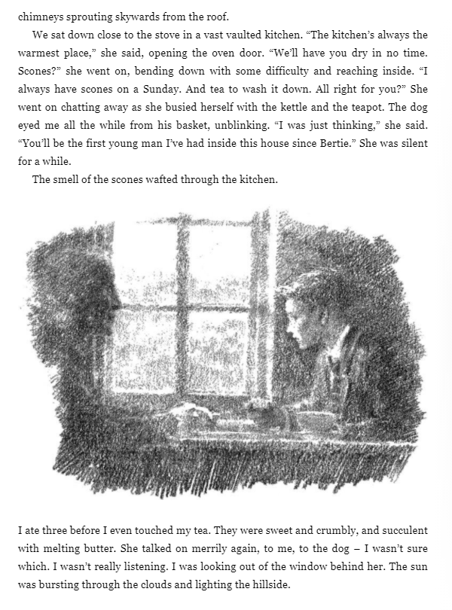

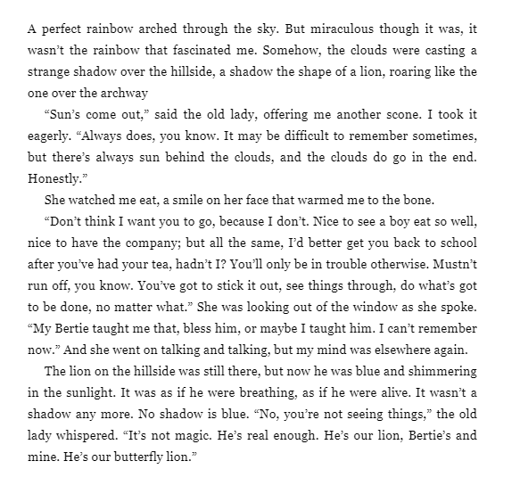

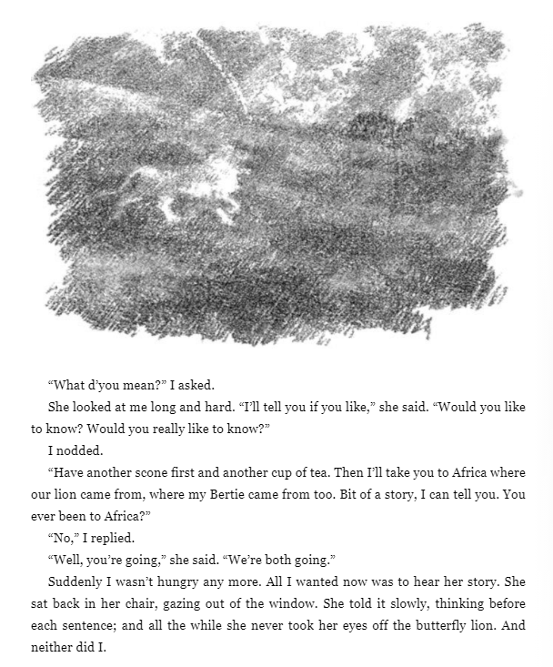

Work

- What is the first impression the writer gives of the old lady on the first page? Can you find examples from the text to back up your point of view.

- On pages 2-3, has the dog changed his impression of the main character? Where is your proof, to support your answer?

- Why do you think the lady pauses after mentioning the name “Bertie”?

- How many scones does the boy eat? Why is he eating so many? Why does the lady smile at that, do you think?

- What does she mean, when she says “Ever been to Africa? . . . Well you’re going . . . We’re both going.”?

- Why do both characters fix on the butterfly lion at the end, do you think?

- Has your impression of the lady changed as the chapter went on? Why?

