A World of Difference

In Maths, the children will be looking at

Year 1

Mass & Weight

Volume & Capacity

Temperature

Measuring and comparing capacity

Comparing and measuring mass

Year 2

Mass & Weight

Volume & Capacity

Temperature

Measuring in millilitres and litres

Measuring in grams and kilograms.

Our English this term will be linked to our theme learning about Magical stories and the theme is Far Far Away.

Children will be writing to write a diary entry and to a narrative about a magical place.

Children will have a range of reading opportunities built into the term. They will have opportunities to read animal stories, and postcards.

There will continue to be daily phonics where children will be developing their knowledge of alternative graphemes. Spellings for Year 1 and 2 children will continue to link directly to their phonic teaching in school.

In **Science** the children will be developing their knowledge of animals through observations, learning about their diets and habitats.

.

**PE/Games**

Art Attack

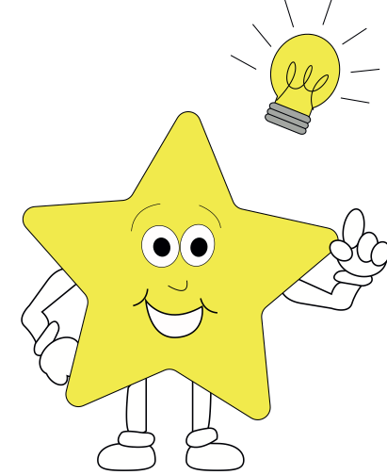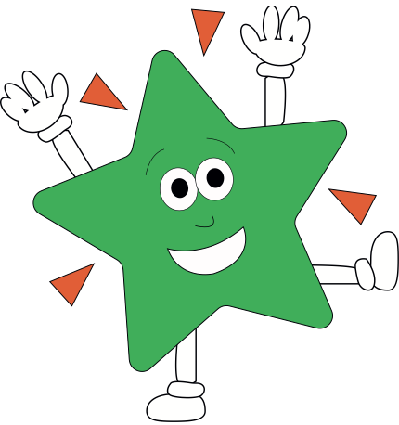

In **History** thechildren will be learning about the history of toys.

In **Art** the children will be learning about the artist Matisse, what sculpture is and what a milliner is.

In **D&T** the children will be learning to design and make a card with a moving part.

In **Music**, children will be learning through rhythms, singing chants and performing what we learn.

In **Computing**, children will be using publisher/Purple Mash/word to create and design a front cover for a magical story.

In RE, the children will be discussing the Qur’an and its similarities to the Bible.

In **PSHE,** the children we be looking at the topic ‘Changing Me.’

